*Florida International University*

*School of Computing and Information Sciences*

CIS 4911 - Senior Project

Software Engineering Focus

Final Deliverable

MYVIPCITY 1.0

**Team Members:**

Angel Parades

Darshana Sebastian

**Product Owner(s)**:

Ali Aliabadi

Arash Shivazad

Hamid-reza Nazemi

**Mentor(s)**: Mohsen Taheri

**Instructor**: Masoud Sadjadi

The MIT License (MIT)

Copyright (c) *2017 Florida International University*

Permission is hereby granted, free of charge, to any person obtaining a copy of this software and associated documentation files (the "Software"), to deal in the Software without restriction, including without limitation the rights to use, copy, modify, merge, publish, distribute, sublicense, and/or sell copies of the Software, and to permit persons to whom the Software is furnished to do so, subject to the following conditions:

The above copyright notice and this permission notice shall be included in all copies or substantial portions of the Software.

THE SOFTWARE IS PROVIDED "AS IS", WITHOUT WARRANTY OF ANY KIND, EXPRESS OR IMPLIED, INCLUDING BUT NOT LIMITED TO THE WARRANTIES OF MERCHANTABILITY, FITNESS FOR A PARTICULAR PURPOSE AND NONINFRINGEMENT. IN NO EVENT SHALL THE AUTHORS OR COPYRIGHT HOLDERS BE LIABLE FOR ANY CLAIM, DAMAGES OR OTHER LIABILITY, WHETHER IN AN ACTION OF CONTRACT, TORT OR OTHERWISE, ARISING FROM, OUT OF OR IN CONNECTION WITH THE SOFTWARE OR THE USE OR OTHER DEALINGS IN THE SOFTWARE.

***Abstract***

*This document presents the information necessary to gain a good understanding of the project MYVIPCITY 1.0 developed during the Spring of 2017 for the Senior Project class.*

*MYVIPCITY 1.0 is a Single Page Application (SPA) that keeps a portfolio of high-end restaurants/clubs and a corresponding list of VIP hosts. Each one of these entities have its own profile page with a social section where the owner of the profile can post comments, images and videos. MYVIPCITY 1.0 allows users to easily search and find high-end restaurants/clubs, as well as submit attending requests for these places.*

*MYVIPCITY 1.0 aims to target those South Florida tourists willing to pay a higher price to have a VIP experience in high-end restaurants/clubs and that many times want to use a VIP Host.*

*This document contains an extensive list of implemented user stories. It also provides a detailed plan of execution that includes hardware and software specifications. System design is explained through specific diagrams. System validation is also discussed. A glossary with essential domain technology can also be found. Finally, in the last chapter the reader can find a series of appendices with UML samples, screenshots and progress reports.*

**Table of Contents**

**Introduction** …………………………………………………………………………………………………………………………….. 5

Current System ……….…………………………………………………………………………………………………………... 5

Purpose of New System …………………………………………………..…………………………………………………... 5

**User Stories**

Implemented User Stories ………………………………………….………………………………………………………..6

Pending User Stories …………………………………………………………………...………………………………..….. 21

**Project Plan**

Hardware and Software Resources ……………………………………………………...……………………….… 21

Sprints Plan ……………………………………………………………..………………………………………………………. 22

*Sprint 1*  …………………………………………………………………………………………………………………………... 22

*Sprint 2*  …………………………………………………………………………………………………………………………... 22

*Sprint 3*  …………………………………………………………………………………………………………………………... 22

*Sprint 4*  …………………………………………………………………………………………………………………………... 23

*Sprint 5*  …………………………………………………………………………………………………………………………... 24

*Sprint 6*  …………………………………………………………………………………………………………………………... 25

*Sprint 7*  …………………………………………………………………………………………………………………………... 25

**System Design**

Architectural Patterns ………………………………………………………………………………………………….. 26

System and Subsystem Decomposition …………………………………………………………………………….… 28

Deployment Diagram …………………………………………………………………………………………………….…... 29

Design Patterns ………………………………………………………………………………………………………….….... 29

**System Validation**  …………………………………………………………………………………………………………………….30

**Glossary**  ………………………………………………………………………………………………………………………………….36

**Appendix**  ………………………………………………………………………………………………………………………………….37

Appendix A - UML Diagrams ………………………………………………………………………………………………. 38

*Static UML Diagrams*  ……………………………………………………………………………………………………….38

*Dynamic UML Diagrams*  …………………………………………………………………………………………………..39

Appendix B - User Interface Design …………………………………………………………………………….…... 51

Appendix C - Sprint Review Reports …………………………………………………………………………...…… 84

Appendix D - User Manuals, Installation/Maintenance Document, Shortcomings/Wishlist Document and other documents …………………………………………………………………….…………… 86

**References** ……………………………………………………………………………………………………………………...………...88

# Introduction

MyVIPCity 1.0 is a web portal that keeps a portfolio of high-end restaurants/clubs and a corresponding list of VIP Hosts. Each restaurant and VIP Host can have a profile page that can be updated with basic information and with social posts like videos, images, and comments.Visitors of the site can easily find and search for restaurants/clubs, navigate through their social posts, and submit attending requests for these places.

## Current System

This is the first version of MyVIPCity. There is no current system.

## Purpose of New System

Create a web portal, which can be used as a tool to enrich the vacation experience of tourists looking to visit high-end restaurants/clubs.

Each business and VIP Host have a profile page with basic information plus a social feed section to post comments, pictures and videos about their activity. There will be an easy search mechanism available for the users which will sort results according to the distance to the user’s geographical location. A rating system will be available, which enables the users to give feedbacks to the VIP hosts.

# User Stories

The following section provides the detailed user stories that were implemented in this iteration of the MYVIPCITY project. These user stories served as the basis for the implementation of the project’s features. This section also shows the user stories that are to be considered for future development.

## Implemented User Stories

**Sprint 1 & Sprint 2**

(1/17/2017- 2/10/2017)

**#117 Create Registration Mechanism for regular user/customer**

As a user I should be able to register by either filing a registration form or using the Google or Facebook account.

### Acceptance Criteria:

1. User should be able to enter the registration form when clicked on the new user signup.
2. User should be able to enter all the necessary information to create an account.
3. User should be able to create a username.
4. User should be able to create a password.
5. User should be able to create an account.

**#118 Create Mechanism to Login in the website**

As a user, I would like to login into the website so that I can use the features that require authentication.

### Acceptance Criteria:

1. User should be able to click on a Login link and be presented with a form with the following fields:
   1. Email Address (this will be the username): this field is a text box.
   2. Password: this field will be a masked text box.
   3. Remember Me, this will be a checkbox.
   4. A LOGIN button that submits the form.
2. The following validation rules should apply on the client side:
   1. If the user selects the Email Address field and leave it without entering something, then a validation error message reading “Email is required” will appear
   2. If the user selects the Password field and leave it without entering something, then a validation error message reading “Password is required” will appear
   3. If the user enters an invalid email, then a validation error message reading “Invalid email” should appear
   4. The validation message error will disappear once the user fix the corresponding error.
   5. The LOGIN button will be disabled if there is at least one validation error preventing the user to submit the form; otherwise it will be enabled.
   6. Once the user submits the form, if an error occurs on the server, then the user must be notified.
      1. If the user enters a wrong password, a message “Invalid login attempt” will appear.
3. There will be a Forgot Password link in case the user forgets his/her password and wants to reset it.
   1. Once the user clicks the Forgot password? link, a new form will appear with one field, Email Address, and a button RESET PASSWORD
   2. The same validation rules used for Email Address in the login form will apply for Email Address in the Forgot Password form
   3. The button RESET PASSWORD will be enabled only when the user has typed a valid email
   4. When the user clicks RESET PASSWORD
      1. If an error occurred on the server, then the user must be notified
      2. If the user provided a valid email which is stored in the database, then an email will be sent to the user with a link to reset the password
      3. Whether the email belongs to a registered user or not, the user should be notified that the email has been sent. This prevents a malicious user from knowing if a specific email is already registered.
      4. Once the user receives the email and clicks the link to reset the password he/she will be taken to the site where a form to reset the password will be presented. The Reset Password form will contain the following fields:
         1. Email (the user will need to enter the email again as a security measure)
         2. New Password (masked)
         3. Confirm New Password (masked)
         4. RESET button.
         5. RESET button will only be enabled when all the fields are valid and populated.
         6. There must be a client side validation to validate the Password and Confirm Password match
4. User should be able to log in using Google account
   1. The user can click a Google icon to be redirected to Google and login using Google OAuth
5. User should be able to log in using Facebook account
   1. The user can click a Facebook icon to be redirected to Facebook and login using FB OAuth
6. Once the user logs in, he will see a Link reading “Hello, <email>” that will be used to log off.

**Sprint 3**

(2/13/2017-2/24/2017)

**#122 Admin User can add a new business**

As an admin user, I would like to be able to Add a new Business so that other users can see it.

### Acceptance Criteria:

1. Once the user is logged in with an Admin account, the user will see a menu **Admin** with a sub-menu **Add Club.**

2. When the admin clicks the Add Menu link, he will be presented with a form to add a new business. The form will have the following fields:

2.1 **Business Name**

2.2 **Business Phrase** (catchy phrase or motto of the business)

2.3 A pictures section where the user can upload pictures for the business (can use drag & drop or click to open file explorer). Once the user uploads the pictures, the user should be able to re-order the pictures and to remove them by clicking a X (remove) icon at the top of the picture.

2.4 The form will have an **Information** section with the following fields:

2.4.1 **Hours**. Here the user can define the hours for the entire week. A list with a short name for the day (Mon, Tue, Wed, etc) will appear and next to it a field **Open Time, Closed Time** where the user can enter the open and close time, and a checkbox **Closed** to specify that the business will be closed that day.

2.4.2 **Ambiance**

2.4.3 **Good for dancing** (this is a checkbox)

2.4.4 **Alcohol** (text)

2.4.5 **Phone** number

2.4.6 **Website** (url)

2.5 **Address** The user should be able to enter the Street, City, State and zip code of the business. As soon as the user enters the address, a map with a marker for that address should appear right below. Also a formatted and correct address will appear. The map and the formatted address will help the admin to the determine if the address he entered is indeed correct.

2.6 **Amenities** User can enter an **Amenities Phrase,** for example “You can enjoy this and more...”. User can enter a list of amenities

2.7 **Details** The details will be a What you see is what you get editor

At the end of the form, there will be a **Save** button used to persist the information .

Note: (Client Side validation of the form will be handled in a different US)

Once the user clicks the save button, the form will be persisted in the database.

A popup should appear notifying the user on whether or not the Save operation was successful.

If the operation is successful, the popup will display a title *Business created successfully!,* text body *Do you want to view the business?* and two buttons: **Yes** and **No.**

If the user clicks **Yes** then he/she will be taken to the view page for the recently added club.

If the user clicks **No** then the form will be cleared so that the user can enter the information of a new business.

**#135 Admin user editing the business details**

As an admin user I should be able to login into the website and should be able to see the businesses and can edit the information.

### Acceptance Criteria:

1. If a regular user logged into the website, the regular homepage will show up and this user will not have any kind of admin privileges like the add club and edit club.

2. When an administrator logged into the website, an admin home page will show up with the menus admin, a sub-tab add club and also with the links to each of the clubs added into the website.

3. After clicking the club name, we will be able to enter into the club information page with a edit tab.

4. When the edit tab have been clicked, a form will be shown in which the admin will be able to edit all the information related to the club.

The form will have the following fields:

4.1 **Business Name**

4.2 **Business Phrase** (catchy phrase or motto of the business)

4.3 A pictures section where the user can upload pictures for the business (can use drag & drop or click to open file explorer). Once the user uploads the pictures, the user should be able to re-order the pictures and to remove them by clicking a X (remove) icon at the top of the picture.

4.4 The form will have an **Information** section with the following fields:

4.4.1 **Hours**. Here the user can define the hours for the entire week. A list with a short name for the day (Mon, Tue, Wed, etc) will appear and next to it a field **Open Time, Closed Time** where the user can enter the open and close time, and a checkbox **Closed** to specify that the business will be closed that day.

4.4.2 **Ambiance**

4.4.3 **Good for dancing** (this is a checkbox)

4.4.4 **Alcohol** (text)

4.4.5 **Phone** number

4.4.6 **Website** (url)

4.5 **Address** The user should be able to enter the Street, City, State and zip code of the business. As soon as the user enters the address, a map with a marker for that address should appear right below. Also a formatted and correct address will appear. The map and the formatted address will help the admin to the determine if the address he entered is indeed correct.

4.6 **Amenities** User can enter an **Amenities Phrase,** for example “You can enjoy this and more...”. User can enter a list of amenities

4.7 **Details** The details will be a What you see is what you get editor

* At the end of the form there will be a save button which will be finished in another user story for the regular users to see the club information.
* After finishing with the editing the admin can change from the edit mode to “ View Read Mode” which will show all the information of the club and also the edited information in read mode.

**#136 View for Business (Business Profile page)**

As a user I would like to see the details of a specific business

### Acceptance Criteria:

1. Any user, either anonymous or authenticated, can see the details of a business that has been previously added to the system.
2. The user can navigate to the local URL /viewClub/friendlyId where friendlyId is a user friendly id. i.e If the name of the business is **A Business Name** then the friendly id will be **a-business-name** (add a hyphen between each word of the name and set it to lowercase)
3. The user will be able to see the READ MODE version of all the fields defined in US [#122](https://fiu-scis-seniorproject.mingle.thoughtworks.com/projects/myvipcity/cards/122).
   1. **Pictures.** The first picture as defined when the business was added will be shown. If the user clicks the picture then he will be able to see all the pictures for this club in a gallery.
   2. **Hours**
      1. If the business was marked as closed for one day, then next to the day show ***Closed***
      2. If the day was not marked as Closed, and no Open/Closed time was provided, then this means the business is opened 24 hours that day. Show ***Opened 2 hours.***
   3. **Website** This will be a clickable link to the corresponding website
   4. **Address**
      1. **​**The formatted address will be show and the map with a corresponding marker for that address.
   5. **Amenities** Each amenity will be show with a different (random) color background.**​**
   6. **Details**: The details should be shown with the semantics defined in the WYSIWYG editor.

**Sprint 4**

(2/27/2017-3/10/2017)

**#120 An admin user can manage the VIP promoters for a business.**

As an admin user, I would like to manage the VIP Hosts/Promoters of a business.

### Acceptance Criteria:

1. An admin user can edit the VIP hosts associated to a club right from the club view once in Edit mode.
2. There will be a card with a header **VIP Hosts** that will be used to manage the VIP promoters
3. In read mode, this card should only show the VIP hosts that have accepted an invitation and that have an existing profile. The picture, name and the average rating of the promoter must be displayed
4. In edit mode:
   1. First, the admin will see the VIP hosts that have accepted an invitation from the club. The admin must be able to remove any existing promoter. Besides showing the picture, name, and average rating, the admin will also see the email associated to the promoter.
   2. Second, Pending Invitations
      1. There will be a section with title **Pending Invitations** where the admin can see the Name and email of the invitations he has sent but have not been accepted yet. The admin must be able to resend the invitation or to delete the invitation. If the invitation is deleted, even if the promoter tries to accept it, he/she won’t be able to join the club.
   3. Third, Add new promoters
      1. The will be a section to add new invitations to new promoters.
      2. There will be a button **ADD PROMOTER**, that when clicked, will display a form to enter the information of the new promoter to be invited. Admin must enter the Name and the Email of the promoter. The admin can remove this entry. The button ADD PROMOTER will be enabled to add a new entry only if the Name and a valid email is entered for the previous entry
      3. If the admin has added at least one new invitation, there will be a button **SEND INVITATION** that will send the invitation to the listed new promoters. This button will be enabled only if the Name and valid emails has been entered for all new promoters. Once Send invitation is clicked, an email with an invitation to join the club must be sent to each listed email. The just added invitation must now appear in the **pending invitations** section

**#121 A promoter can accept the invitation to join a business**

As a promoter, I would like to be able to receive invitations to join a business.

### Acceptance Criteria:

1. When an user receives an invitation to join the club in his/her email, he/she will be able to accept the invitation by clicking the Accept Invitation button sent on the body of the email.
2. When the user clicks the Accept invitation button he will be taken to the MyVIPCity site. The invitation is only intended for the recipient of the email, and in order to accept the invitation the user must be authenticated with the corresponding email.
3. If when taken to the MyVIPCity site, the user is not authenticated, then there should be a message letting the user know he needs to log in or register using the same email where the invitation was received.
4. After the user logs in, he will be presented with a screen where he can see the picture of the club that invited him and where there is a button to Accept the invitation.
5. Once the user clicks on Accept invitation on the MyVipCity site, a new profile will be created for this user and he will be taken to the profile page. The first time the owner of the profile visits the profile page, he will be presented with a welcome to profile pop up.
6. One a Promoter user is authenticated, there should be a menu entry with title **My Promoter Profile**, as a submenu there will be an entry for each club where the user is a vip promoter at. The submenu will read as the name of the corresponding Club. Clicking a submenu will take the user to the corresponding promoter profile page.

**#124 Edit Promoter Profile**

### As a registered promoter user, I would like to login into the website and be able to see the list of the businesses where I am a promoter/VIP host at, view the profile and edit the promoter profile as I want.

### Acceptance Criteria:

1. If a regular user logged into the website, the regular homepage will show up and this user will not have any kind of promoter privileges like edit promoter profile.
2. When a promoter logged into the website, a promoter home page will show up with the menu MY PROMOTER PROFILE, and also with the lists of the businesses where that user is a promoter.
3. After clicking a particular business from the list of businesses, we will be able to enter into the promoter profile for that business with an edit tab.
4. When the edit tab have been clicked, a form will be shown in which the promoter will be able to edit all the information related to the profile like changing the name, profile picture.
5. The updated information must be saved when clicked on the save button.

**Sprint 5**

(3/13/2017-3/24/2017)

**#125 An Admin user can Add Posts for a business and all users can see the posts**

As an Admin user, I would like to be able to add Post to a business. The goal is to maintain a social feed for the business.

### Acceptance Criteria:

1. Once an admin user is logged in and in the page of a business, he can scroll to After the Details section.
2. Here there will be three buttons, POST PICTURE, POST VIDEO, and POST COMMENT
3. POST PICTURE
   1. When the button is clicked, there will appear a form to add a post with pictures. There will be a drop zone where the user can either add images by drag and drop or by browsing its file explorer.
   2. There will be a text box to enter a caption for the picture or group of pictures.
   3. There will be two buttons, POST and CANCEL
      1. Clicking Cancel will close the form
      2. POST will be enabled if there is at least one picture uploaded. Once it is clicked, the post will be saved and displayed as the first one on the list of posts
4. POST VIDEO
   1. When the button is clicked, there will appear a form with two text boxes. URL to enter the URL of a Youtube or VIMEO video. Caption to enter a caption or comment for the video
   2. POST button will be enabled only if there is a URL. Clicking POST will save the post and show it at the top of the list
   3. Clicking CANCEL will close the form
5. POST COMMENT
   1. When the button is clicked, there will appear a form with a text input to enter a comment.
   2. POST button will be enabled only if the text is non-empty. Clicking POST will save it and show it at the top of the list
   3. Clicking CANCEL will close the form.
6. Right below the three buttons to add the different type of posts, we will show the list of all the posts. Posts will be shown 6 at a time and sorted decreasing by post date and time. Once the user reached the bottom of the list, there will be a button to LOAD MORE posts that will bring the next 6 posts.
7. Each card containing a post will:
   1. Display the date and time where the posts was added
   2. Comment post will display the text of the comment
   3. Video Post will contain the video itself so that it can be watched right there
   4. Picture post will contain the first picture in the group. The user can click or tap the picture to show the entire gallery
   5. If the user is an admin, there will also be two buttons at the top-right corner of a post card. A button to EDIT and a button to DELETE the post.
      1. DELETE will simply delete the post and remove it from the list
      2. EDIT will display the edit mode for the corresponding type of post as described previously
8. If the user is not an ADMIN the, he/she will only see the read mode of the posts. Meaning that he/she cannot add, edit, or remove posts.

**#126 A Promoter can add a posts to its profiles and all users can see the posts**

As a Promoter user, I would like to be able to add Post to my profiles. The goal is to maintain a social feed for the profile.

### Acceptance Criteria:

The acceptance criteria is the same as the criteria defined in US 125. With the following exceptions

1. The promoter profile will contain a tab with the name POST

2. Posts will be managed under this tab in the same way they are managed for a business (see US[#125](https://fiu-scis-seniorproject.mingle.thoughtworks.com/projects/myvipcity/cards/125) for details)

**#150 Users can add Reviews to a Promoter Profile**

As a user I would like to add a review to a Promoter

### Acceptance Criteria:

1. On the promoter profile page, there will be a tab named **Reviews**
2. Under this tab, there will be a list of all reviews that have been added for the specific promoter profile
3. The review will consist of
   1. A header with the text **By <reviewerUser> on Month DD, yyyy** where reviewer user is the user who added the profile
   2. A rating displayed from 0 to 5 stars
   3. A Comment
4. On top of the list of reviews there will be a button **Add Review**
5. **Add Review** will be visible for all users except the user who owns the profile. The promoter cannot add a review to itself
6. In order to add a review, the user must be logged in.
   1. If the user is not logged in, then, when ADD REVIEW is clicked, display a popup asking the anonymous user to log in first
   2. If the user is Authenticated then when the user clicks ADD REVIEW button ADD REVIEW will disappear and a form to submit a review will appear
      1. The form will have a rating stars control (where the user can mark from 0 to 5 stars in intervals of 0.5). Entering a rating is mandatory.
      2. Once the user selects the rating by clicking the corresponding star, a text box will appear where the user can enter an optional comment.
      3. Two buttons, SUBMIT REVIEW and CANCEL. If CANCEL is clicked, then the review form will disappear and the ADD REVIEW button will appear again
      4. If SUBMIT REVIEW is clicked then, the make the following validations:
         1. The user did not add previous review for the same promoter profile in the last 3 days. (Otherwise, notify the user about this)
         2. If the review contains a Comment and such comment contains inappropriate/obscene words (f** word, etc) then notify the user and ask him to change those words.
      5. If the review is successfully submitted, then add it to the top of the list of reviews. Update the total number of reviews on the promoter profile header. If the page is refreshed, then the Average Rating displayed next to the picture of the promoter is updated accordingly.
      6. Once a review is added, an email will be sent to the promoter profile notifying about a new review on its page. The email must contain the rating and the comment.
7. If the authenticated user is an Administrator, then reviews can be deleted by clicking the CROSS icon at the top-right corner of the review

**Sprint 6**

(3/27/2017-4/7/2017)

**#123 Search and filtering of restaurants/clubs**

As a user, I would like to be able to find and filter restaurants.

### Acceptance Criteria:

1. In the home page, we will allow the user to find and search/filter for restaurants.
2. The home page will show a text input where the user can type a search criteria. The search criteria will be applied to following fields:
   1. Name of the place
   2. Full formatted address (including all components: street, city, state, zip code, country)
3. Results must be ordered increasingly by distance to the current location of the user. (That is, the geographical distance between the location of the user and the location of the restaurant)
4. We will try two methods to get an approximation of the geographical coordinates of the user:
   1. Locate user using the IP address from the device making the request to the server
   2. Ask the user for permission to get its coordinates. This is method is more accurate, but the user could deny the request, in which case we will use the location obtained in 4.1
   3. As soon as the user opens the home page, we will show results based on its IP location, and quickly prompt the user for its permission to use its location (see 4.2). If the user accepts then we will update the list of results using the latter location.
5. When the user types a search text, then the list of results will show only those items that match the text.
   1. Each result item consists of a picture of the restaurant, the address, and the distance from the current location to the restaurant.
   2. Each matched text must be highlighted.
6. If the user clicks a result item, then it will be taken to the corresponding page of the restaurant.

**#157 User can submit and attending request for a restaurant**

As a registered user, I would like to send an attending request to a restaurant/club.

### Acceptance Criteria:

1. The user should be able to communicate the restaurant his intention to go to the restaurant.
2. In the page of a specific restaurant there will be a form used for this purpose.
3. The form will contain the following fields:
   1. Name of the user (required)
   2. Contact Number (required)
   3. Date when the user wants to go (required)
   4. The total number of people that will go (required)
   5. The number of women (required)
   6. The number of men (required)
   7. The service the user wants (required)
      1. VIP Table Service
      2. or Priority General Entry
   8. A dropdown to select a desired VIP Host (optional)
   9. An optional message
4. Once the user submits a request the following will happen:
   1. IF the user selected a desired VIP Host, then an email will be sent to the corresponding VIP host notifying him about the attending request (A Bcc will be sent to each administrator of the sire). The email will contain all the information entered by the user. The recipient VIP will click an ACCEPT or DECLINE button. Once the VIP host clicks either button, he will be taken to the site where he can actually accept or decline the request.
      1. IF the VIP host accepts the attending request, then an email (Bcc each admin) will be sent back to the user notifying that the request has been accepted and everything is set up.
      2. IF the VIP host declines the request, then an email will be sent to each administrator of the site notifying that the corresponding VIP hosts declined the request and asking the admin to assign a new VIP host for this request. The admin can click an ASSIGN PROMOTER button to assign a new promoter (see 3)
   2. IF the user did not select a VIP host, then an email will be sent to each admin notifying that there is a new attending request but a VIP host was not selected. The email will ask the admin to assign a promoter for the request.
   3. Admin assigns a promoter
      1. Once the admin clicks the assign button, he will be taken to the site where he can select a new promoter. Once the admin selects a new promoter, an email will be sent to that new promoter and the cycle starts again as if the user had selected such promoter from the beginning (see 1)
      2. The admin will also have the ability to decline the request, in which case an email will be sent to original user notifying his request has been declined.

**#158 From the view of a business, suggest other businesses to the user**

As an user I would like to see suggestions for other restaurants once I am in the view of a specific restaurant.

### Acceptance Criteria:

1. In the view of a restaurant, there will be a card with header “You may also like” that will show the 5 other restaurants closed to this one.

**Pending User Stories**

There are no pending user stories as we have completed all planned user stories for MyVIPCity 1.0.

# Project Plan

This section describes the planning that went into the realization of this project. This project incorporated the agile development techniques defined in the SCRUM methodology, which requires a sprint planning session at the beginning of each sprint. These sprint plannings are detailed in this section. This section also describes the components, both software and hardware, chosen for this project.

## Hardware and Software Resources

The following sections will describe the environments needed (both software and hardware) for the proper development and deployment of the application.

**Development Environment**

In order to develop the application, the following hardware specs are recommended:

* A Windows Computer
* Min of 4 GB of RAM
* At least 30 GB of disk space
* At least 2.0 Ghz processor

For software development, developers are recommended to have working knowledge of the following programming languages/technologies/software:

* HTML5, CSS3, Less
* JavaScript / AngularJS
* C# / MVC and WebApi
* TRANSACT-SQL
* Visual Studio IDE
* Microsoft SQL Server
* Internet Information Services (IIS)

**Deployment Requirements**

* The project is targeted for deployment on a Windows based server
* The deployed application must be served by the web server **Internet Information Services (IIS)**. We used IIS 10 for this version.
* An active Sendgrid account. This is the service the application uses for sending notifications. An API key is required from sendgrid in order to successfully run the application.

## Sprints Plan

**Sprint Plan Report**

**Sprint 1 & 2**

Attendees: Angel Paredes, Darshana Sebastian

Start time: 1/19/2017 8:15pm

End time: 1/19/2017 8:35pm

After discussion, the velocity of the team was estimated to be 16 points

The product owner chose the following user stories to be done during the next sprint. They are ordered based on their priority.

* User Story

**#117: Create Registration Mechanism for regular user/customer**

**#118 : Create Mechanism to Login in to the website**

The team members indicated their willingness to work on the following user stories.

* Angel, will work on

User Story **#118 : Create Mechanism to Login in to the website**

* Darshana will work on

User Story **#117: Create Registration Mechanism for regular user/customer**

**Sprint 3**

Attendees: Angel Paredes, Darshana Sebastian

Start time: 02/10/2017 8:15pm

End time: 02/10/2017 8:35pm

After discussion, the velocity of the team was estimated to be 32 points

The product owner chose the following user stories to be done during the next sprint. They are ordered based on their priority.

* User Story

**#122: Admin User can add a new business**

**#135: Admin user editing the business details**

**#136: View for Business**

The team members indicated their willingness to work on the following user stories.

* Angel, will work on

User Story **#122: Admin User can add a new business**

User Story **#136: View for Business**

* Darshana will work on

User Story **#135: Admin user editing the business details**

**Sprint 4**

Attendees: Angel Paredes, Darshana Sebastian

Start time: 02/24/2017 8:15pm

End time: 02/24/2017 8:35pm

After discussion, the velocity of the team was estimated to be 28 points

The product owner chose the following user stories to be done during the next sprint. They are ordered based on their priority.

* User Story

**#120: Admin User can manage the VIP promoters for the business**

**#121: A promoter can accept the invitation to join a business**

**#124: Edit Promoter Profile**

The team members indicated their willingness to work on the following user stories.

* Angel, will work on

User Story **#120 : Admin User can manage the VIP promoters for the business**

User Story **#121: A promoter can accept the invitation to join a business**

* Darshana will work on

User Story **#124: Edit Promoter Profile**

**Sprint 5**

Attendees: Angel Paredes, Darshana Sebastian

Start time: 03/10/2017 8:15pm

End time: 03/10/2017 8:35pm

After discussion, the velocity of the team was estimated to be 28 points

The product owner chose the following user stories to be done during the next sprint. They are ordered based on their priority.

* User Story

**#125 : An Admin user can Add Posts for a business and all users can see the posts**

**#126: A Promoter can add a posts to its profiles and all users can see the posts**

**#150: Users can add Reviews to a Promoter Profile**

The team members indicated their willingness to work on the following user stories.

* Angel, will work on

User Story **#125 : An Admin user can Add Posts for a business**

User Story **#126: A Promoter can add a posts to his profile**

* Darshana will work on

User Story **#150: Users can add Reviews to a Promoter Profile**

**Sprint 6**

Attendees: Angel Paredes, Darshana Sebastian

Start time: 03/24/2017 8:15pm

End time: 03/24/2017 8:35pm

After discussion, the velocity of the team was estimated to be 26 points

The product owner chose the following user stories to be done during the next sprint. They are ordered based on their priority.

* User Story

**#123 : Search and filtering of restaurants**

**#157: User can submit and attending request for a restaurant**

**#158: From the view of a business, suggest other businesses to the user**

The team members indicated their willingness to work on the following user stories.

* Angel, will work on

User Story **#157 :User can submit and attending request for a restaurant**

User Story **#158 : From the view of a business, suggest other businesses**

* Darshana will work on

User Story **#123: Search and filtering of restaurants**

**Sprint 7**

No more user stories left,both Angel and Darshana will be working on the documentation.

# 

# System Design

This section contains information on the design decisions that went into this project. The architecture patterns are outlined and explained. The entire system is shown in a package diagram and the subsystems are explained. Finally, the design patterns used in the project are discussed.

## Architectural Patterns

## MyVipCity 1.0 is architectured as a four layers system: Application Layer, Services Layer, Business Logic Layer and Data Layer.

## Application Layer

The application or presentation layer is the layer that the user directly interacts with. For the first version of MyVipCity, the user will be interacting with a web application, more specifically, a Single Page Application (SPA).

In this layer resides all the client side code for the site: HTML5, Javascript, CSS3, MVC Views, images, AngularJS directives, controllers, services, etc..

## Services Layer

In this layer resides a REST API that responds to requests made from the application layer using the HTTP protocol. This layer serves as the bridge between the Application Layer and the Business Layer. All the data that is read/written in MyVipCity must go through the REST endpoints defined in this layer in the form of Data Transfer Objects (DTOs). All the operations (i.e create, read, update, delete) exposed in this layer delegate its core functionality into the Business Layer.

## Business Layer

This layer manipulates all the domain objects; that is, it manages all the operations that can be executed over these objects -- create, modify, add, delete. It also validates the rules dictated by the business, that is, it runs the business rules. For example, in this layer, it is validated that the same user cannot add more than one review to the same VIP host within a three day period. This is an example of a business rule that is triggered when a new review is being added for a VIP host. This layer delegates into the Data layer to persist and retrieve data from the data source.

In this layer, DTOs are transformed into instances of domain classes (i.e **BusinessDto bDto** is transformed into **Business b**) and vice versa.

This layer heavily uses the Dependency Inversion Principle (The D in the SOLID principles).

## Data Layer

The data layer is in charge of actually persisting the domain or business objects as records into their corresponding tables in the database. It also reads data from the data source (Microsoft SQL Server Database) and instantiate domain classes with this data. The domain objects are then sent back to the Business Layer.

**Microservices**

We could also claim that MyVIPCity shallowly dives into the world of microservices. The concrete implementation of two of the services (interfaces) used in MyVipCity use an external service. One is SendGrid, which is used to send transactional emails, and the other service is IpInfoDatabase, used to find geographical coordinates given an IP address.

## 

## 

## 

## System and Subsystem Decomposition

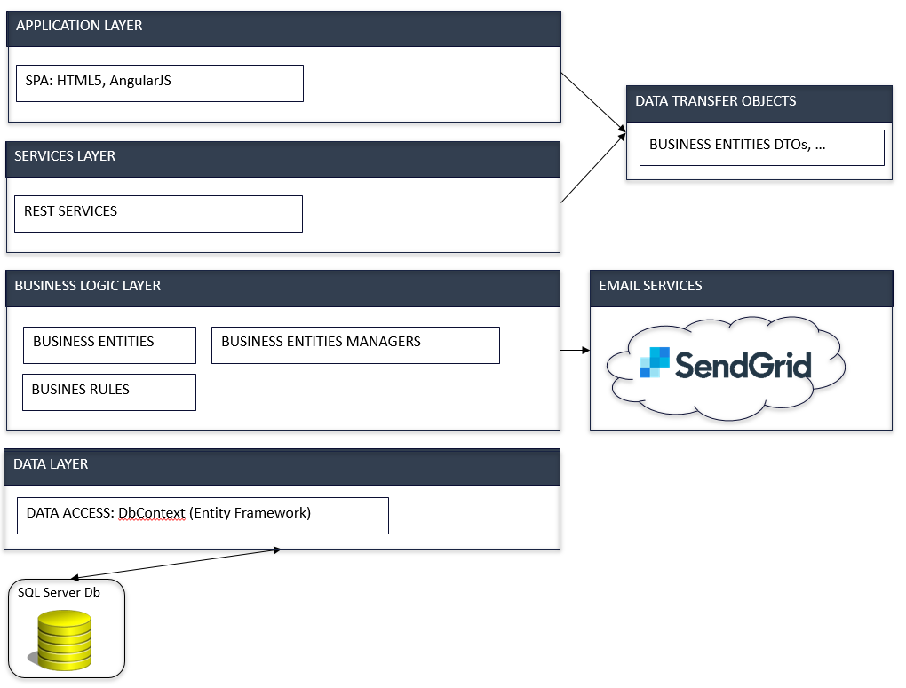

## 

## 

## Deployment Diagram



## Design Patterns

**Singleton**: Entities manager classes used in the Business Layer are instantiated with a Singleton lifecycle, that is, the same instance of these classes is used throughout the lifecycle of the application.

**Dependency Injection:** MyVIPCity uses SimpleInjector framework as a .NET Dependency Injection library for the development of the application. This allows us to easily compose objects and to follow the Dependency Inversion Principle, which allows us to have classes that depend on abstractions (interfaces) instead of details (concrete implementations).

The code, both client and server side, written for the development of MyVIPCity 1.0 tries to adhere as much as possible to the SOLID principles of Object Oriented Programming. Classes are written striving for low coupling and high cohesion. Classes have a specific single responsibility and they should have only one reason to change.

# System Validation

**User Story # 117 : Create Registration Mechanism for regular user**

|  |  |
| --- | --- |
| **Purpose** | Register user into the system |
| **Precondition** | User have access to the application |
| **Input** | * Email Address * Password * Confirm Password |
| **Expected Results** | * User is registered and a confirmation email is sent to the provided email address. * User confirms the email address * User able to login |
| **Actual Results** | *Same as Expected* |
| **Test Result** | Pass |

**User Story # 118 : Create Login Mechanism for regular user**

|  |  |
| --- | --- |
| **Purpose** | Login registered user into the system |
| **Precondition** | User should be already registered |
| **Input** | * Email address * Password |
| **Expected Results** | User able to login |
| **Actual Results** | *Same as Expected* |
| **Test Result** | Pass |

**User Story # 122 : Admin user can add a new Business**

|  |  |
| --- | --- |
| **Purpose** | To add add new businesses |
| **Precondition** | User should have admin privileges |
| **Input** | * Click Add Restaurant * Fill out the form that follows and save it |
| **Expected Results** | New business is created and can be viewed in the home page |
| **Actual Results** | *Same as Expected* |
| **Test Result** | Pass |

**User Story # 135 : Admin user editing the business details**

|  |  |
| --- | --- |
| **Purpose** | To edit the business details |
| **Precondition** | User should have admin privileges |
| **Input** | * Click Edit tab in a business profile * Save the changes |
| **Expected Results** | The changes have been updated |
| **Actual Results** | *Same as Expected* |
| **Test Result** | Pass |

**User Story # 136 : View Business**

|  |  |
| --- | --- |
| **Purpose** | To view a business |
| **Precondition** | The user should have access to the application |
| **Input** | * Clicking on a business profile |
| **Expected Results** | Viewing the business profile |
| **Actual Results** | *Same as Expected* |
| **Test Result** | Pass |

**User Story # 120 : Admin user can manage the VIP promoter for the business**

|  |  |
| --- | --- |
| **Purpose** | Manage the VIP host/promoter for a business |
| **Precondition** | User should have admin privileges |
| **Input** | Enter the edit tab of the business and then click on the Add promoter button |
| **Expected Results** | Admin should able to add new promoter |
| **Actual Results** | *Same as Expected* |
| **Test Result** | Pass |

**User Story # 121 : A promoter can accept an invitation to join a business**

|  |  |
| --- | --- |
| **Purpose** | To accept an invitation as a promoter |
| **Precondition** | The user should get an invitation to be a promoter |
| **Input** | * User clicks on the email invitation * User is taken into the website where he can edit the profile information |
| **Expected Results** | User gets the email invitation and is taken into the website. |
| **Actual Results** | *Same as Expected* |
| **Test Result** | Pass |

**User Story # 124 : Edit Promoter Profile**

|  |  |
| --- | --- |
| **Purpose** | To edit a promoter profile |
| **Precondition** | The user should be logged in and should be a promoter |
| **Input** | Promoter edits his profile information and saves it |
| **Expected Results** | The edited information become available to all other users |
| **Actual Results** | *Same as Expected* |
| **Test Result** | Pass |

**User Story # 125 : Admin User adding posts for a business**

|  |  |
| --- | --- |
| **Purpose** | Adding posts for a business |
| **Precondition** | * Business should be already registered * User should have admin privileges |
| **Input** | User clicking Post Picture,Video and Comment and uploading the same |
| **Expected Results** | The uploaded posts become available to all the users |
| **Actual Results** | *Same as Expected* |
| **Test Result** | Pass |

**User Story # 126 : Promoter adding posts to his profile**

|  |  |
| --- | --- |
| **Purpose** | To add posts to a promoter profile |
| **Precondition** | * The user should be a registered promoter * The user should be logged in |
| **Input** | User clicking Post Picture,Video and Comment and uploading the same |
| **Expected Results** | The uploaded posts become available to the user |
| **Actual Results** | *Same as Expected* |
| **Test Result** | Pass |

**User Story # 150 : Users can add reviews to a promoter profile**

|  |  |
| --- | --- |
| **Purpose** | To add reviews to a promoter profile |
| **Precondition** | * User is logged in * VIP Host profile opened * REVIEWS tab selected. * Current Average Rating = 4 * #Reviews = 1. |
| **Input** | * New average rating = 4.5 * #Reviews increased by one |
| **Expected Results** | * Average rating = 4.5 * #Reviews = 2 |
| **Actual Results** | *Same as Expected* |
| **Test Result** | Pass |

**User Story # 123 : Search and filtering of restaurants**

|  |  |
| --- | --- |
| **Purpose** | To search and filter the restaurants |
| **Precondition** | * The user should have access to the application * The user should be in the home page |
| **Input** | * Click the search text field in the home page and then search for a particular item within a search item. |
| **Expected Results** | User got the exact result item and clicking on it takes him to the result home page |
| **Actual Results** | *Same as Expected* |
| **Test Result** | Pass |

**User Story # 157 : User submitting an attending request to a restaurant**

|  |  |
| --- | --- |
| **Purpose** | To send an attending request to a restaurant |
| **Precondition** | * User should be logged in |
| **Input** | * Select a business from the available list of businesses and from the profile click on the want to go form |
| **Expected Results** | User was able to give an attending request and got a confirmation email |
| **Actual Results** | *Same as Expected* |
| **Test Result** | Pass |

**User Story # 158 : From the view of a business, suggest other businesses to the user.**

|  |  |
| --- | --- |
| **Purpose** | To view the suggestions for other restaurants |
| **Precondition** | * The user should be in the view of a business |
| **Input** | Select a specific restaurant from the available list and go its view |
| **Expected Results** | User should be able to see the list of available restuarants in the places “you may also like” and should be able to go to their corresponding page when clicked on a restaurant . |
| **Actual Results** | *Same as Expected* |
| **Test Result** | Pass |

# Glossary

Administrator : The person who is in charge of the entire application. He can add, edit and

delete business and VIP hosts/ promoters.

VIP Hosts/ Promoters : These are the people who will host the events or promote a business

Registered User : A user who is registered with the website who can make use of the

provision to attend a business

Guest : A user who is not registered with the website but can view all the

information given, but cannot give an attend request.

## Appendix A - UML Diagrams

## 

**Dynamic UML Diagrams**

**# 117 : Registration Mechanism for Users**

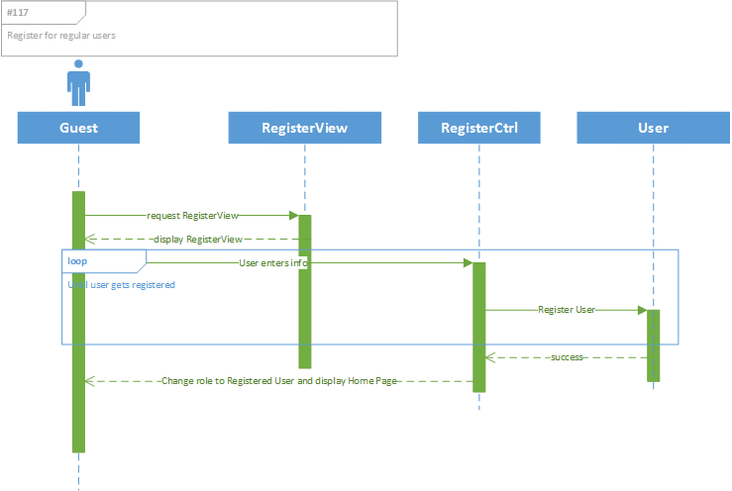

**# 118 : Create Login Mechanism**

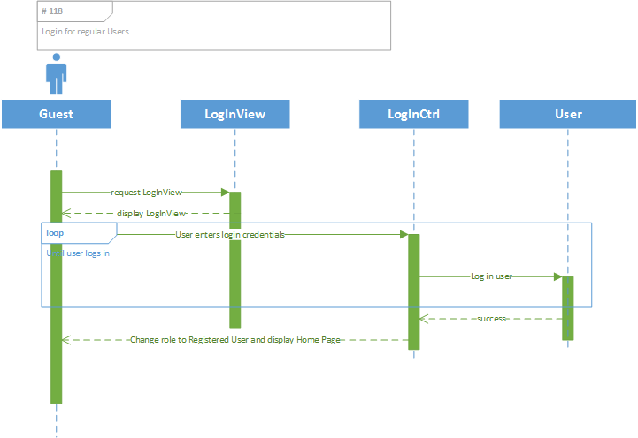

**# 122 :Admin User can add a Business**

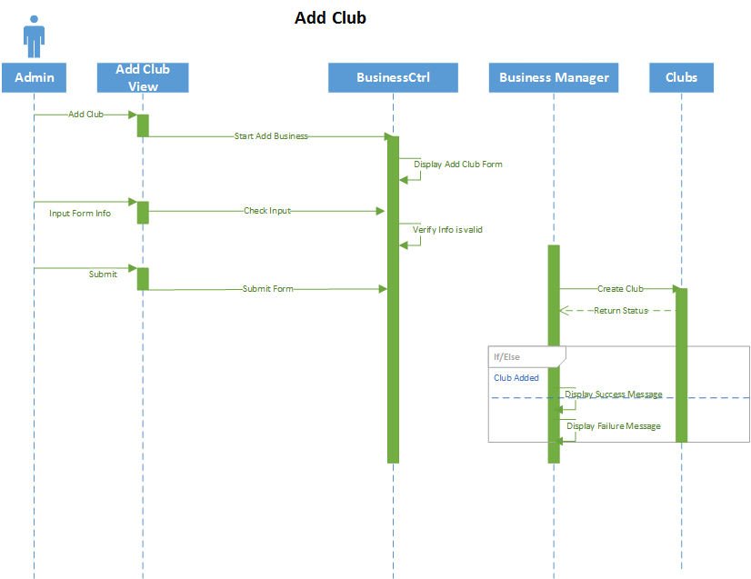

**#135 : Admin user editing the Business Details**

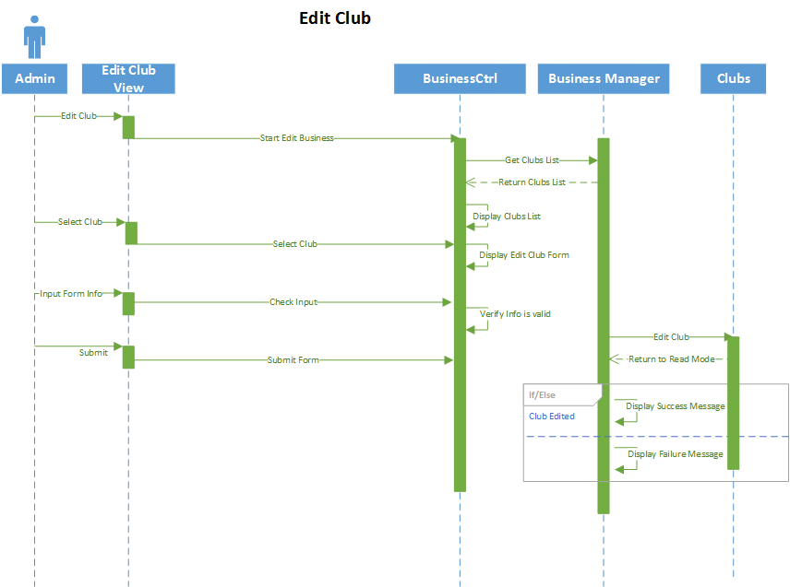

**#136 : View Business**

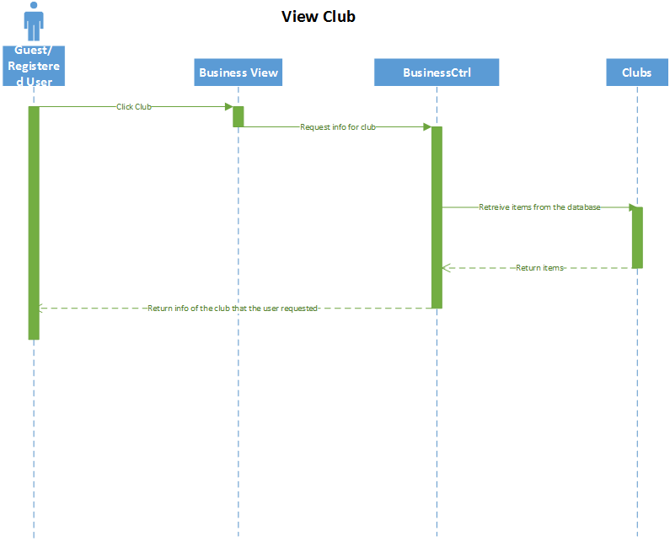

**# 120 : Admin User adding a promoter**

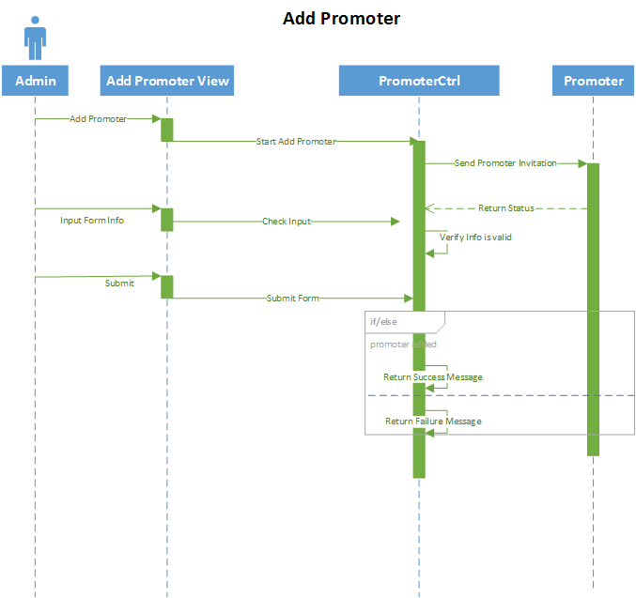

**# 124 : Editing Promoter Profile**

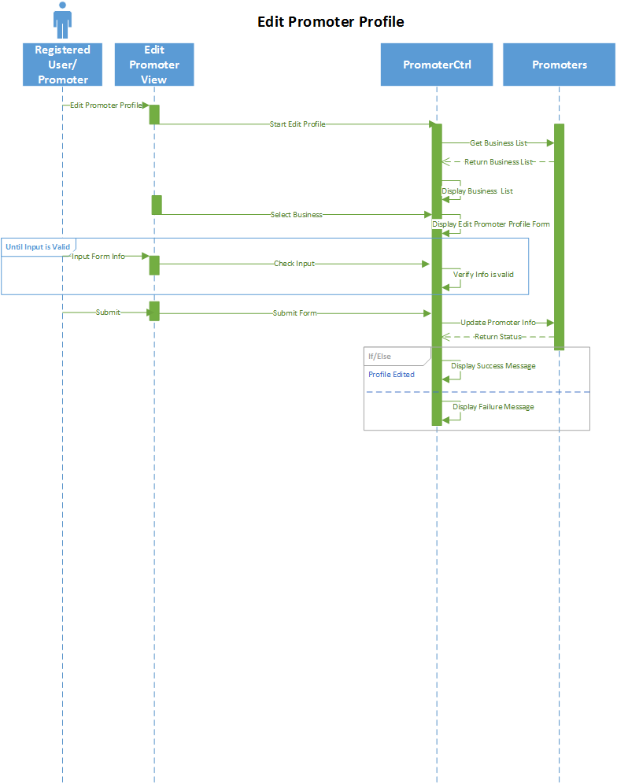

**# 125 : Admin User adding the posts to a Business**

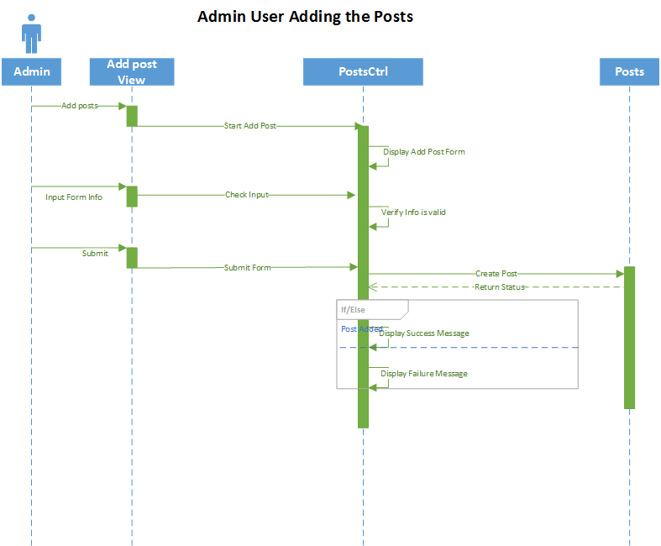

**# 126 : Promoter adding the posts**

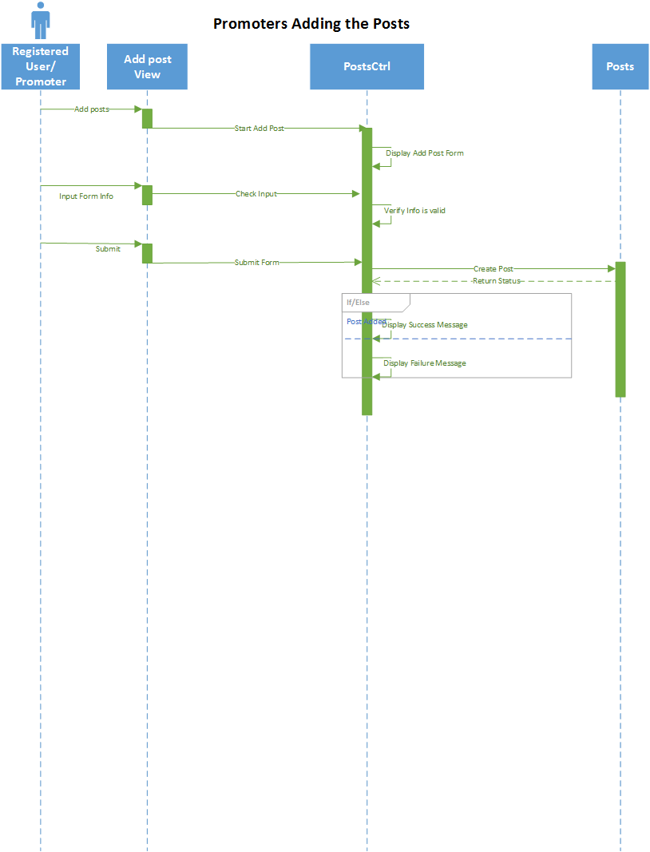

**# 150 : Registered User giving review to the promoters**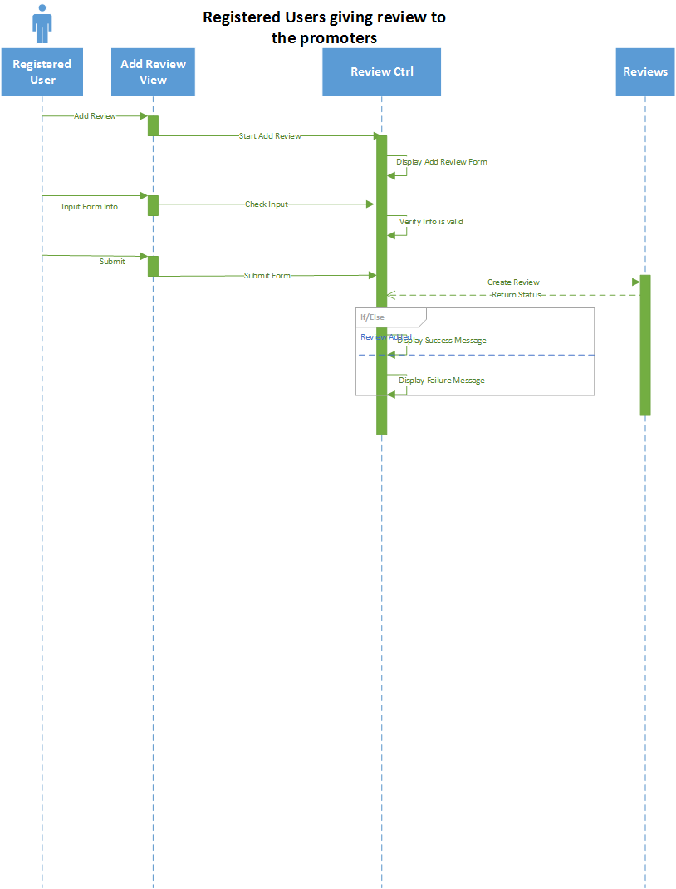

**# 123 : Searching and Filtering of Businesses**

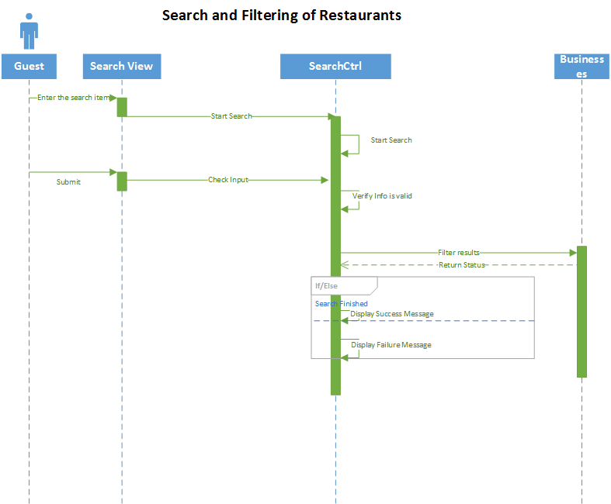

# **157 : User submitting the Attending Request**

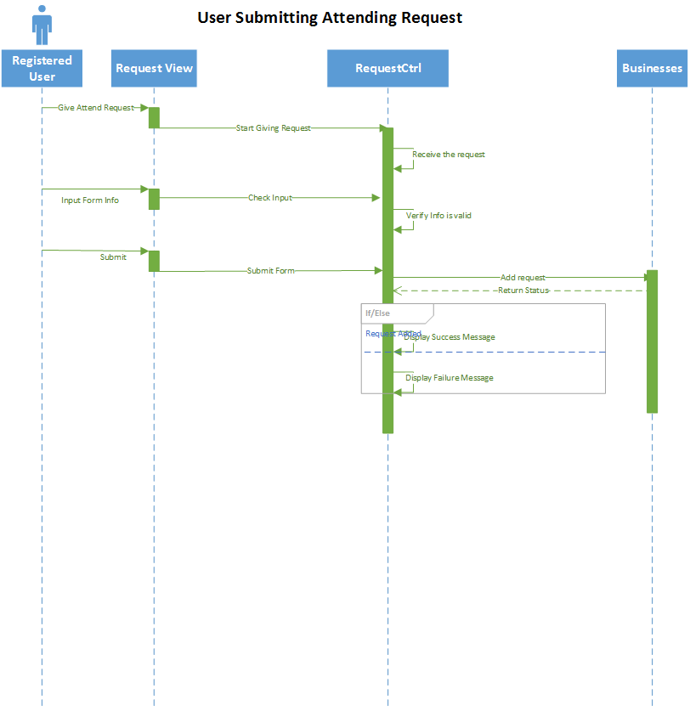

**# 158 : Suggesting other Businesses**

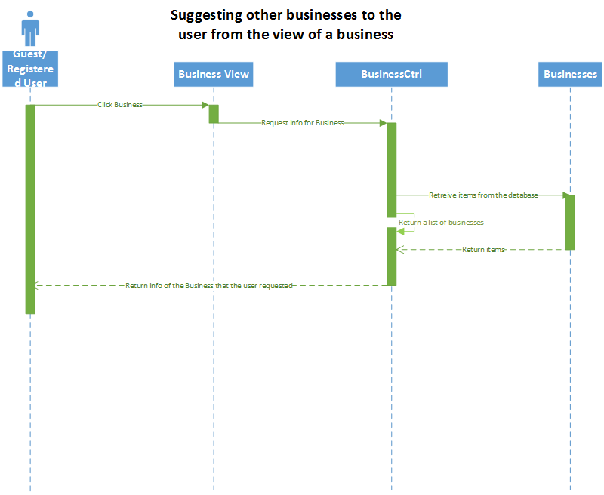

## 

## 

## 

## Appendix B - User Interface Design

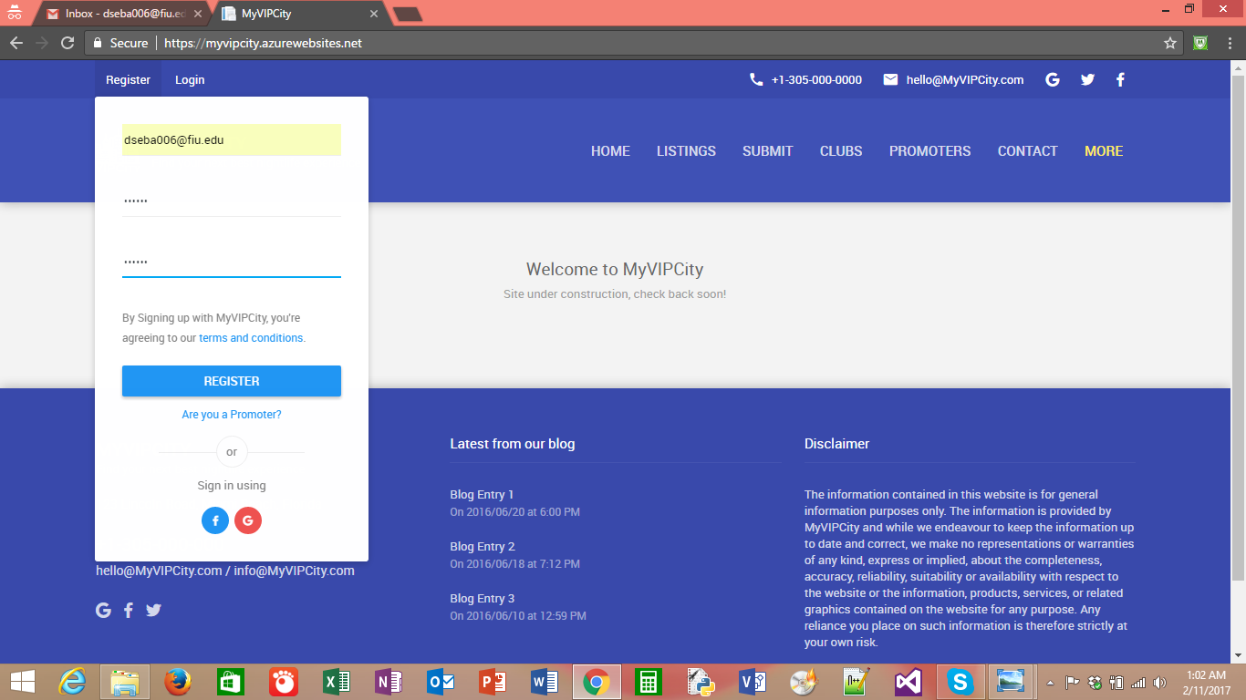

Fig : Entering the email address and password for registration

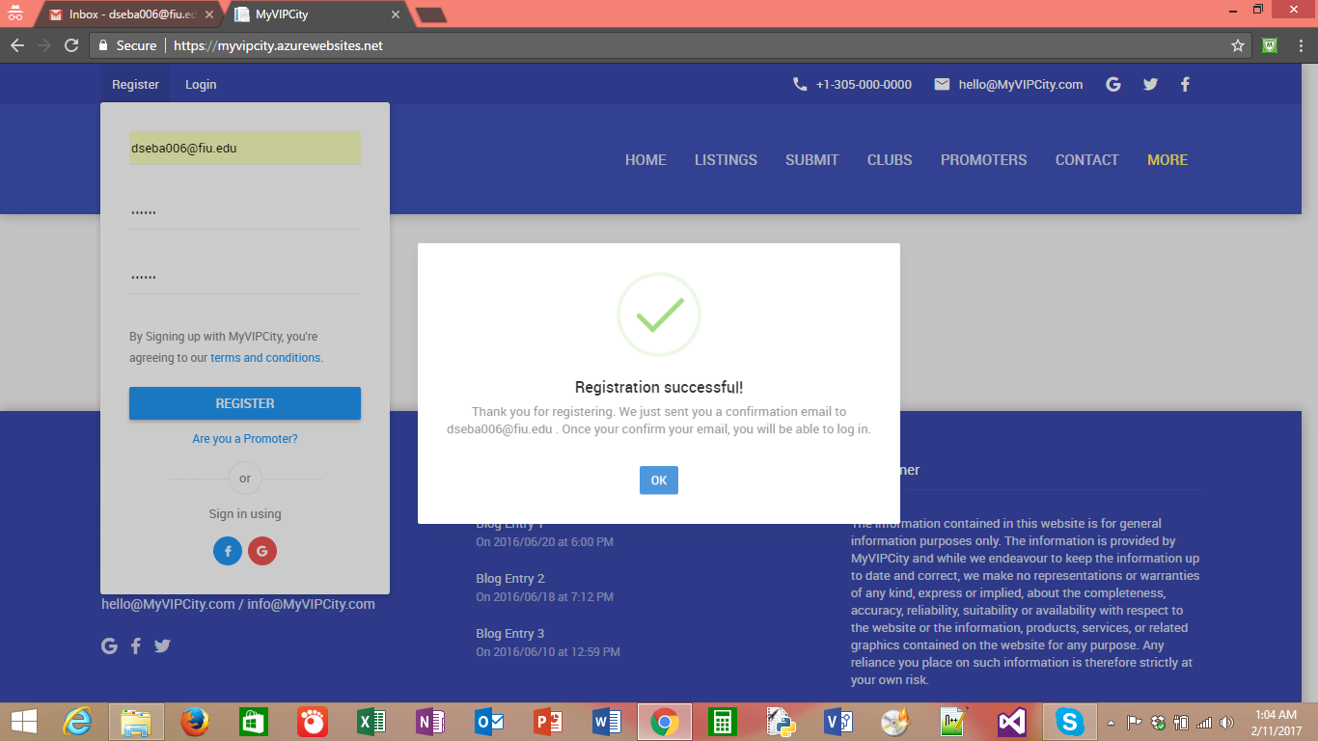

Fig : Registration successful, sending confirmation email

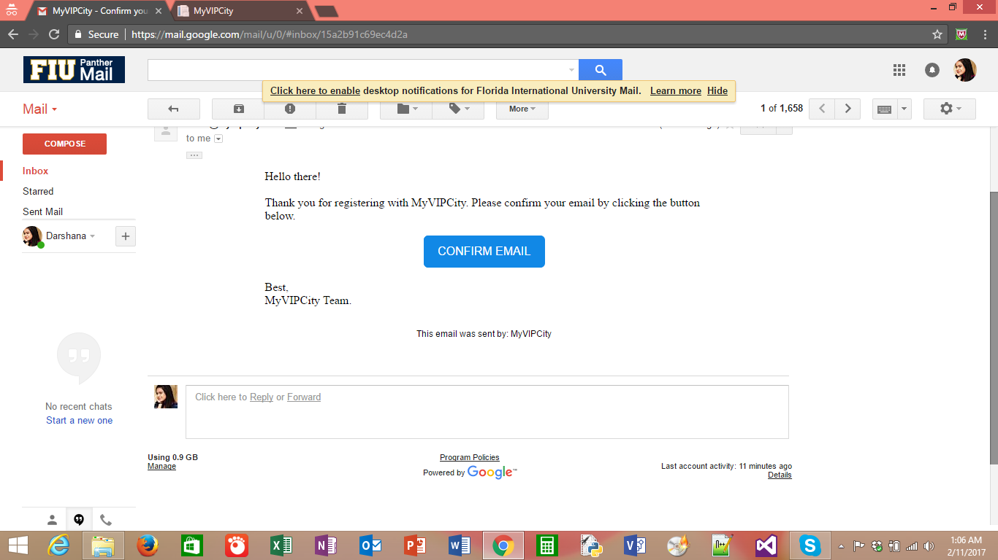

Fig : Received confirmation email for the user to click the confirm email link

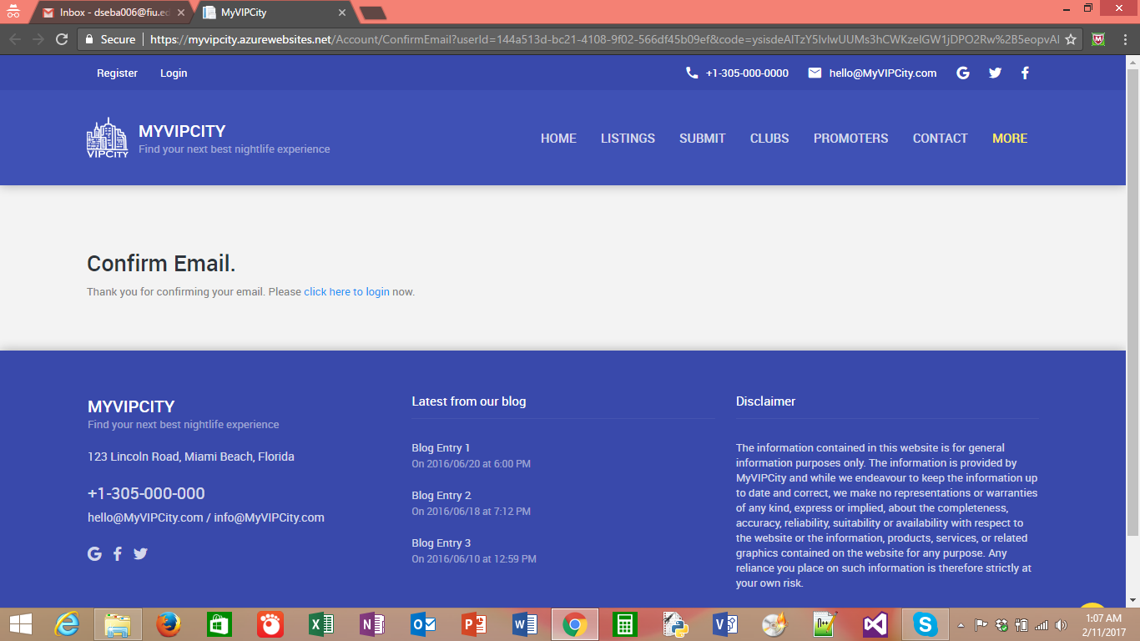

Fig : Email is confirmed , now the user can login

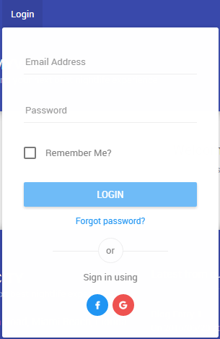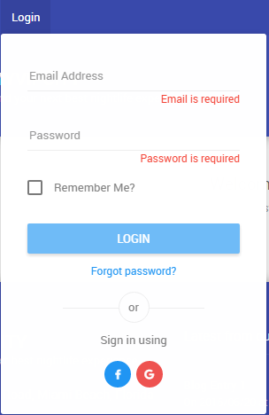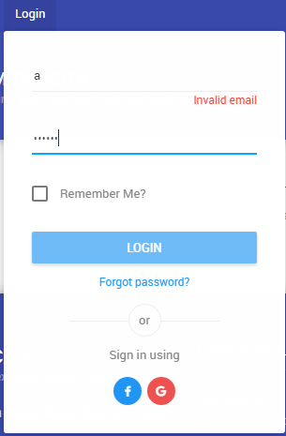

Login Login validation Invalid Email

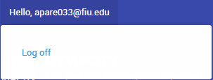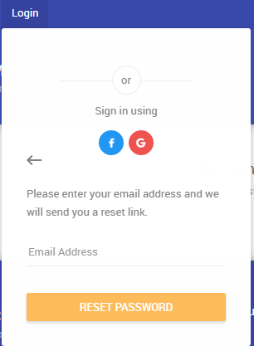

Reset Password

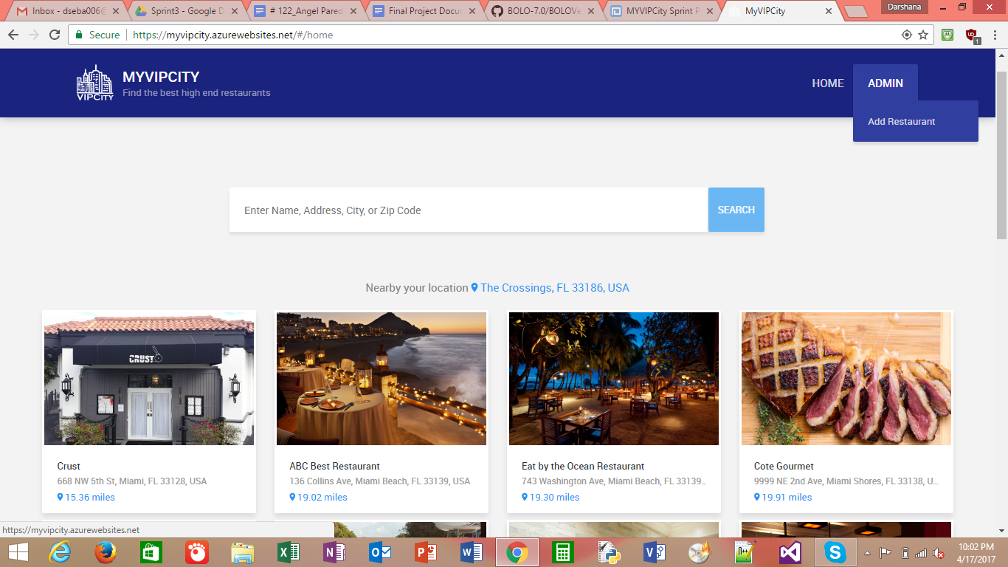

Fig : Admin adding restaurant

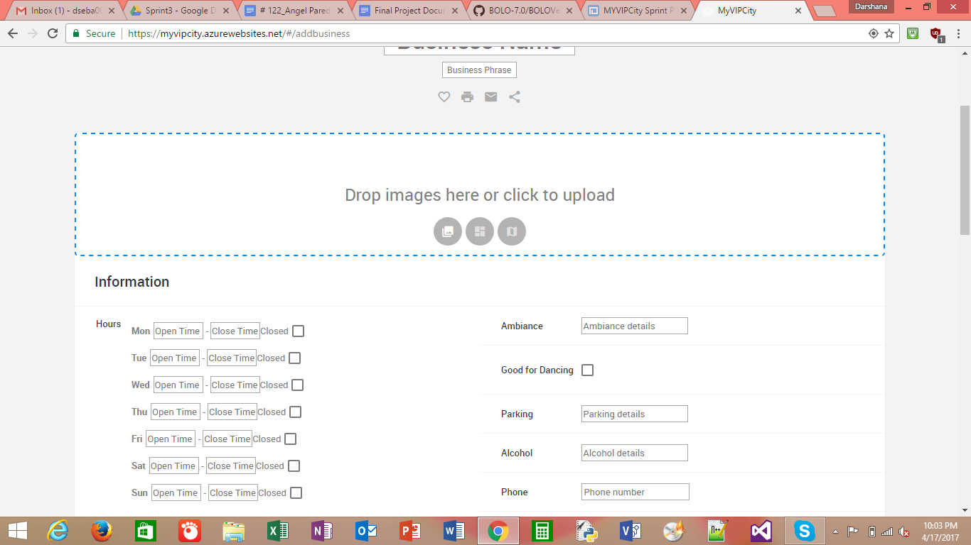

Fig : Form to enter the Business information

Fig : Edit Business profile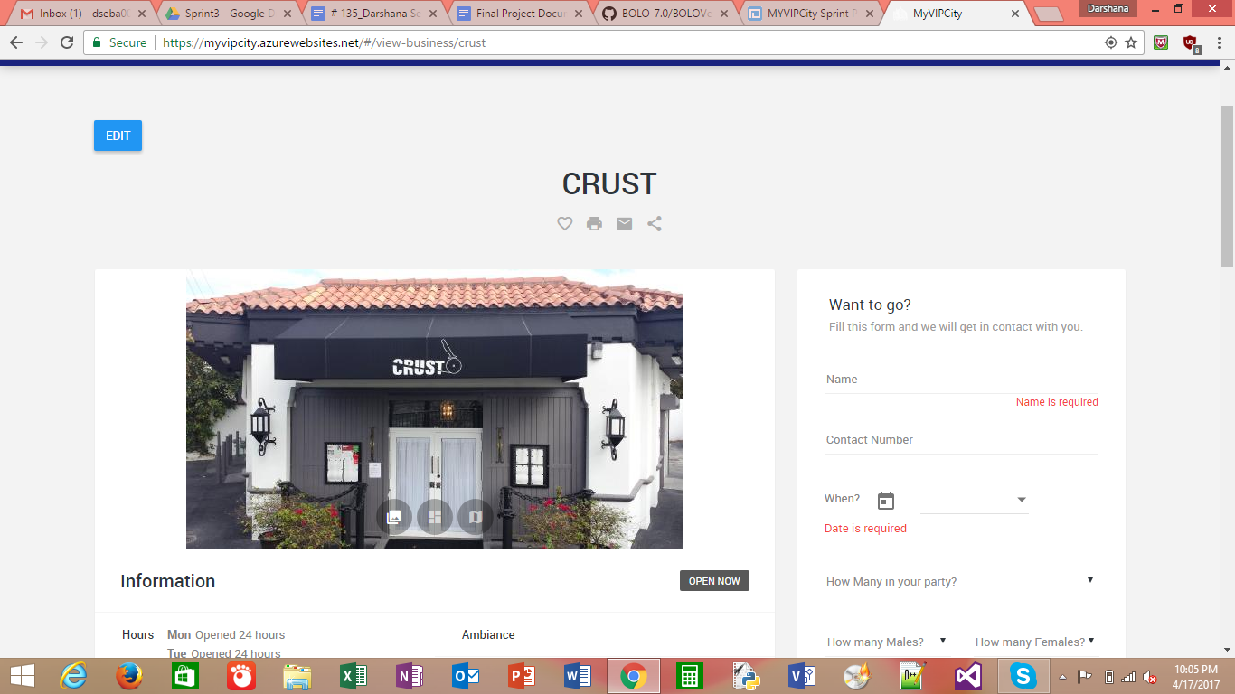

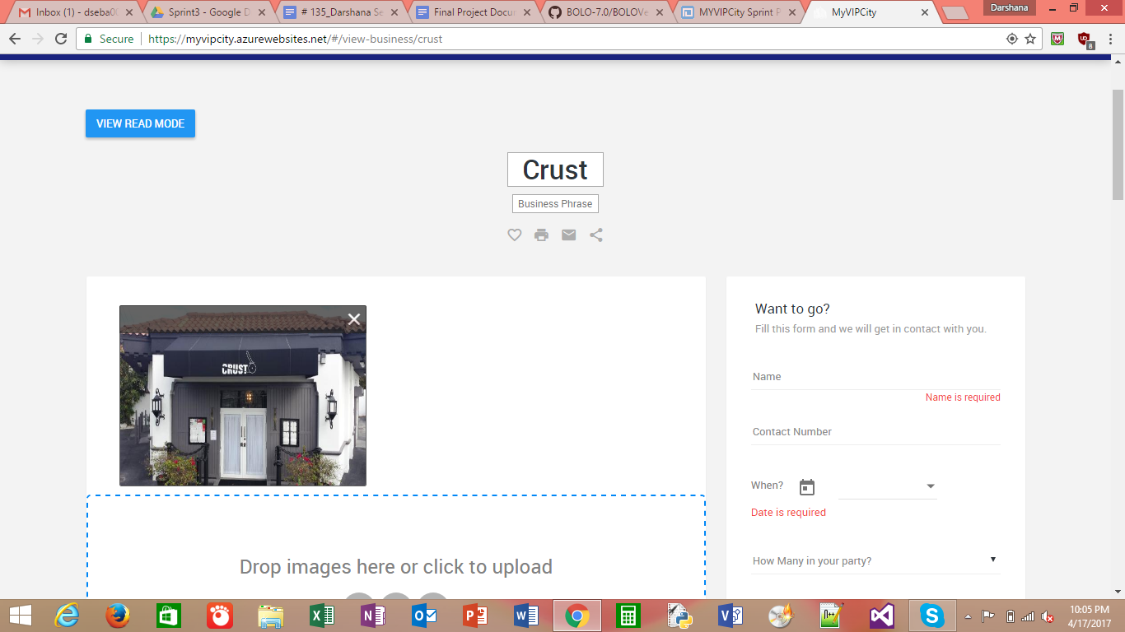

Fig : Edit Mode of the Business profile

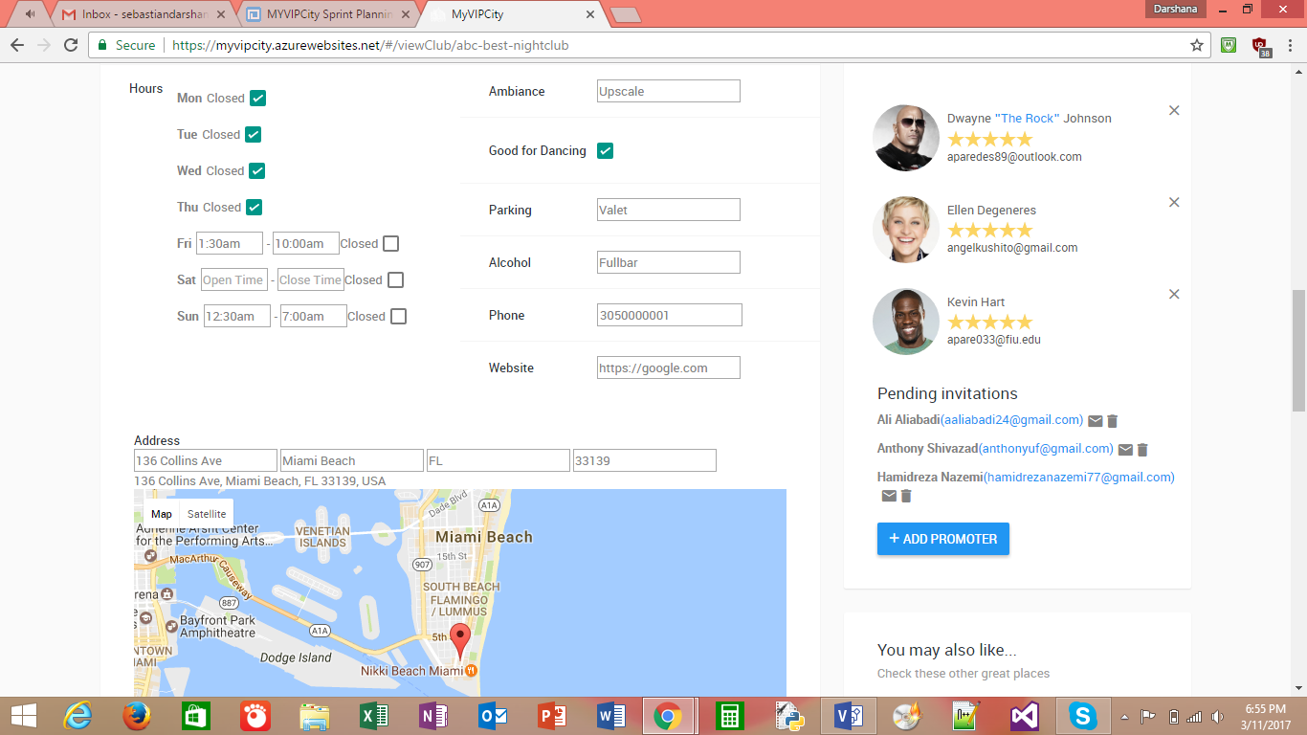

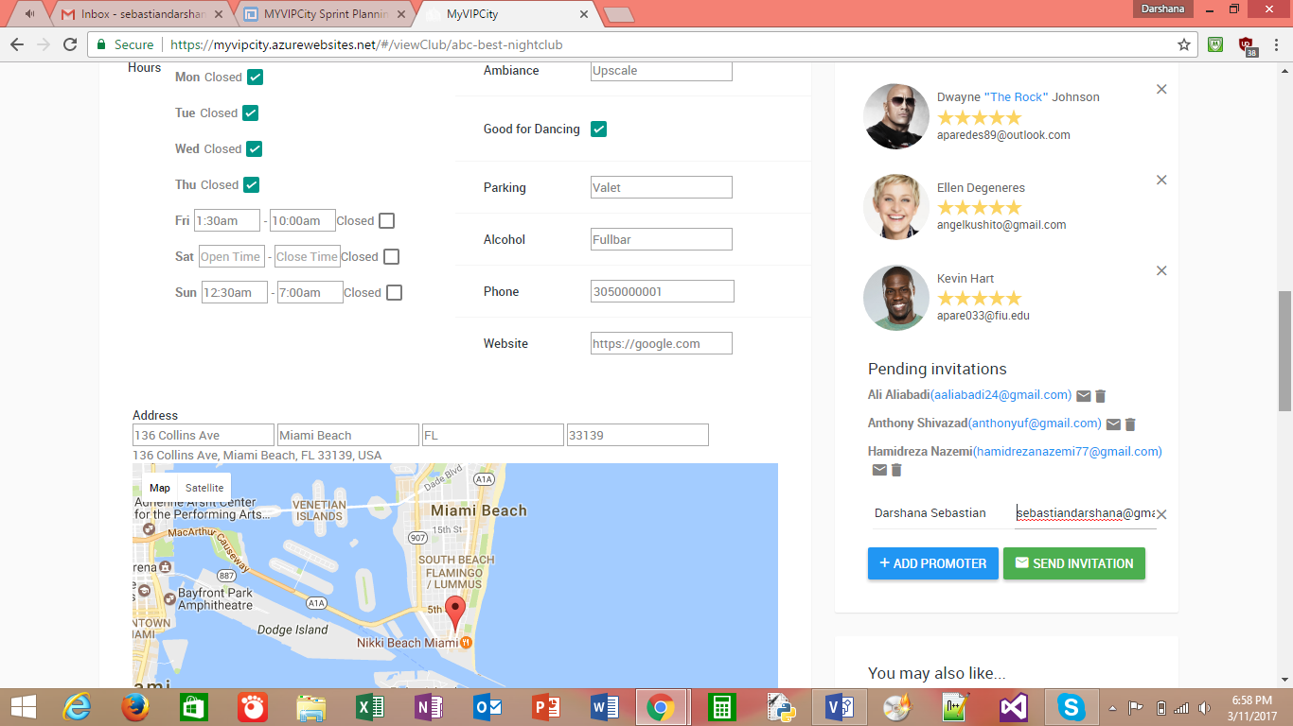

Fig : Sending Promoter Invitation

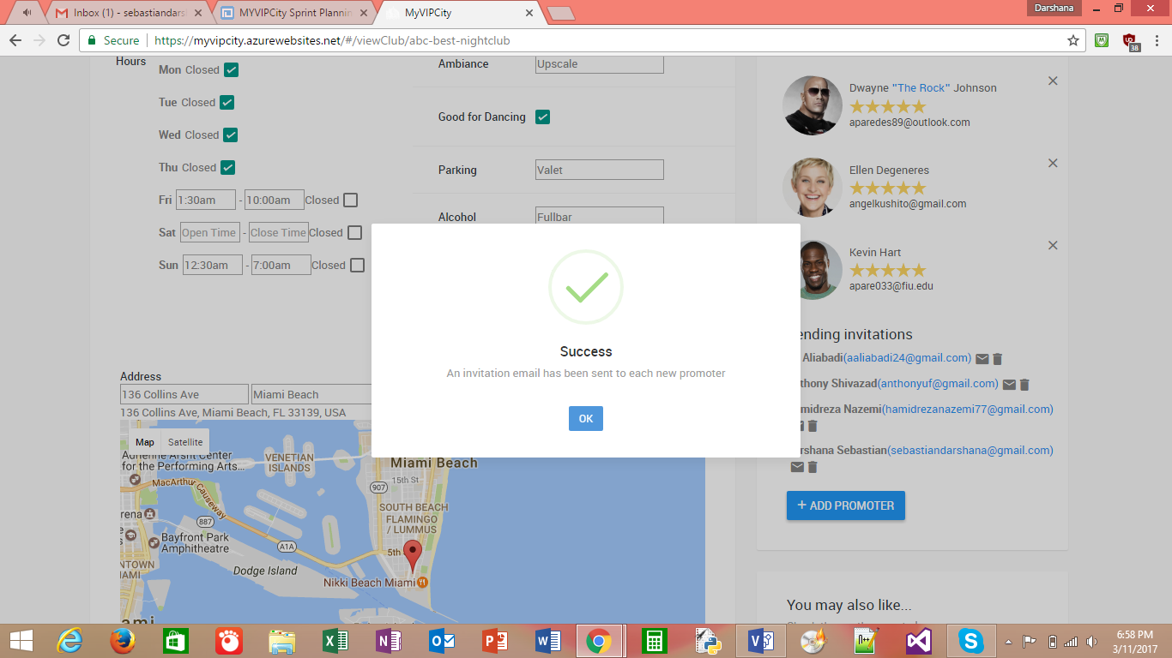

Fig : Invitation email to the promoter

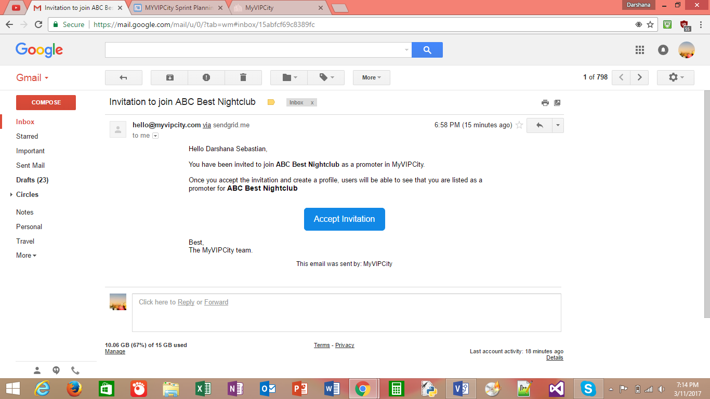

Fig : An invitation email of the promoter

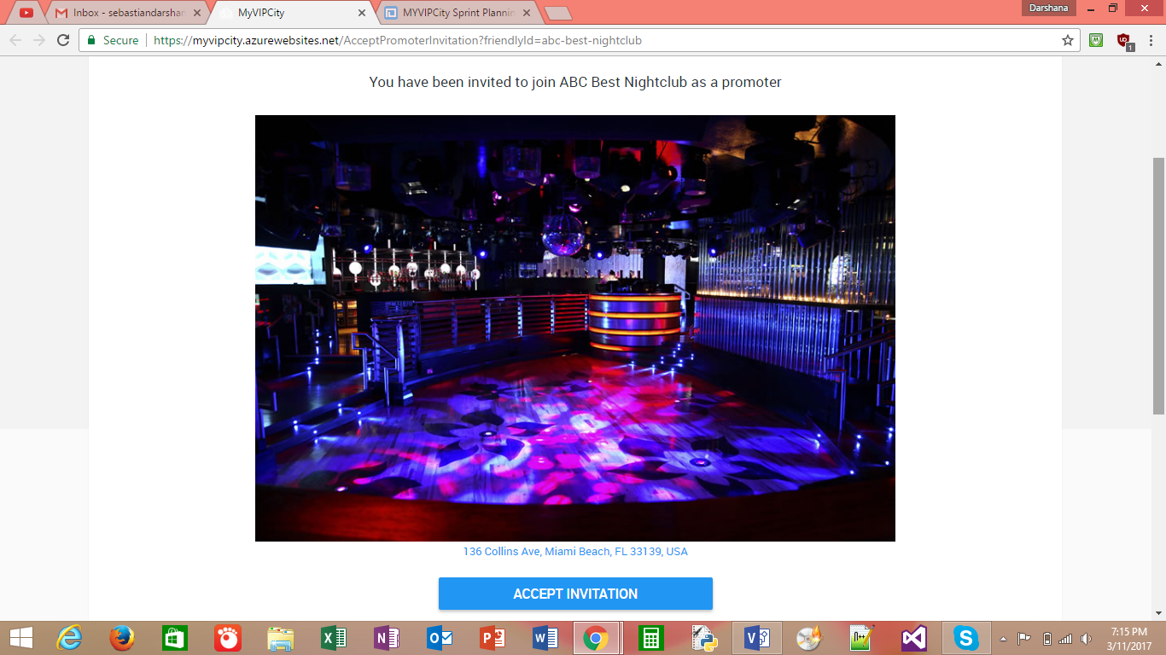

Fig : The accept link for a promoter when he login into the website

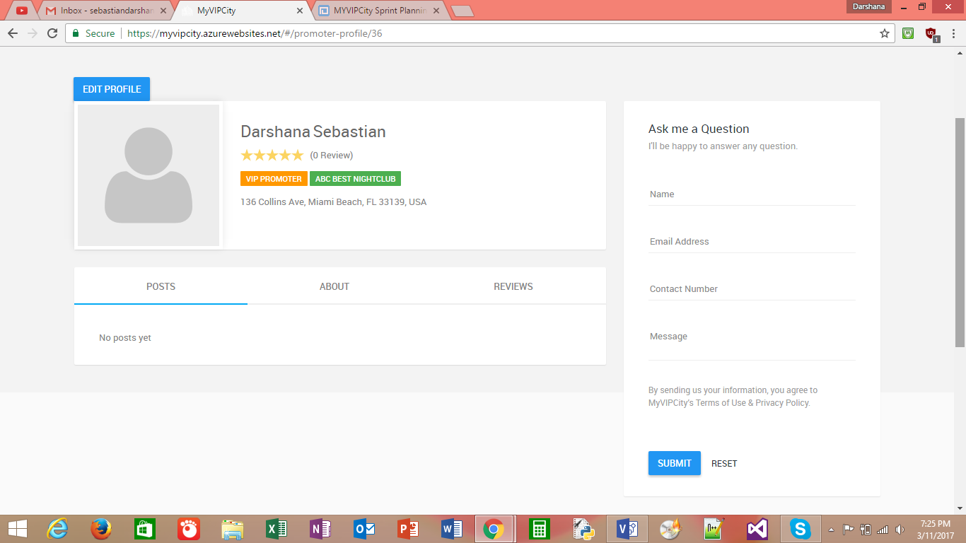

Fig : Promoter Profile

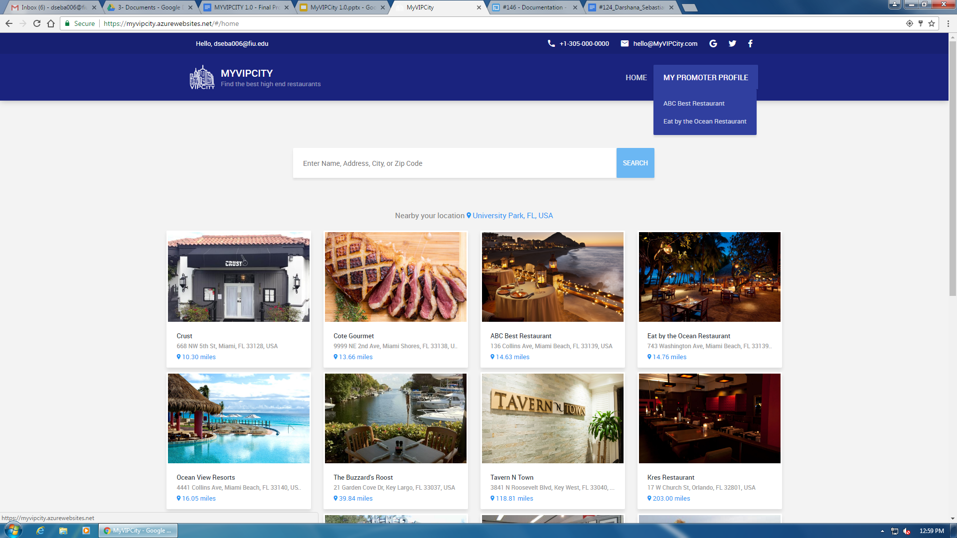

Fig : Promoter home page

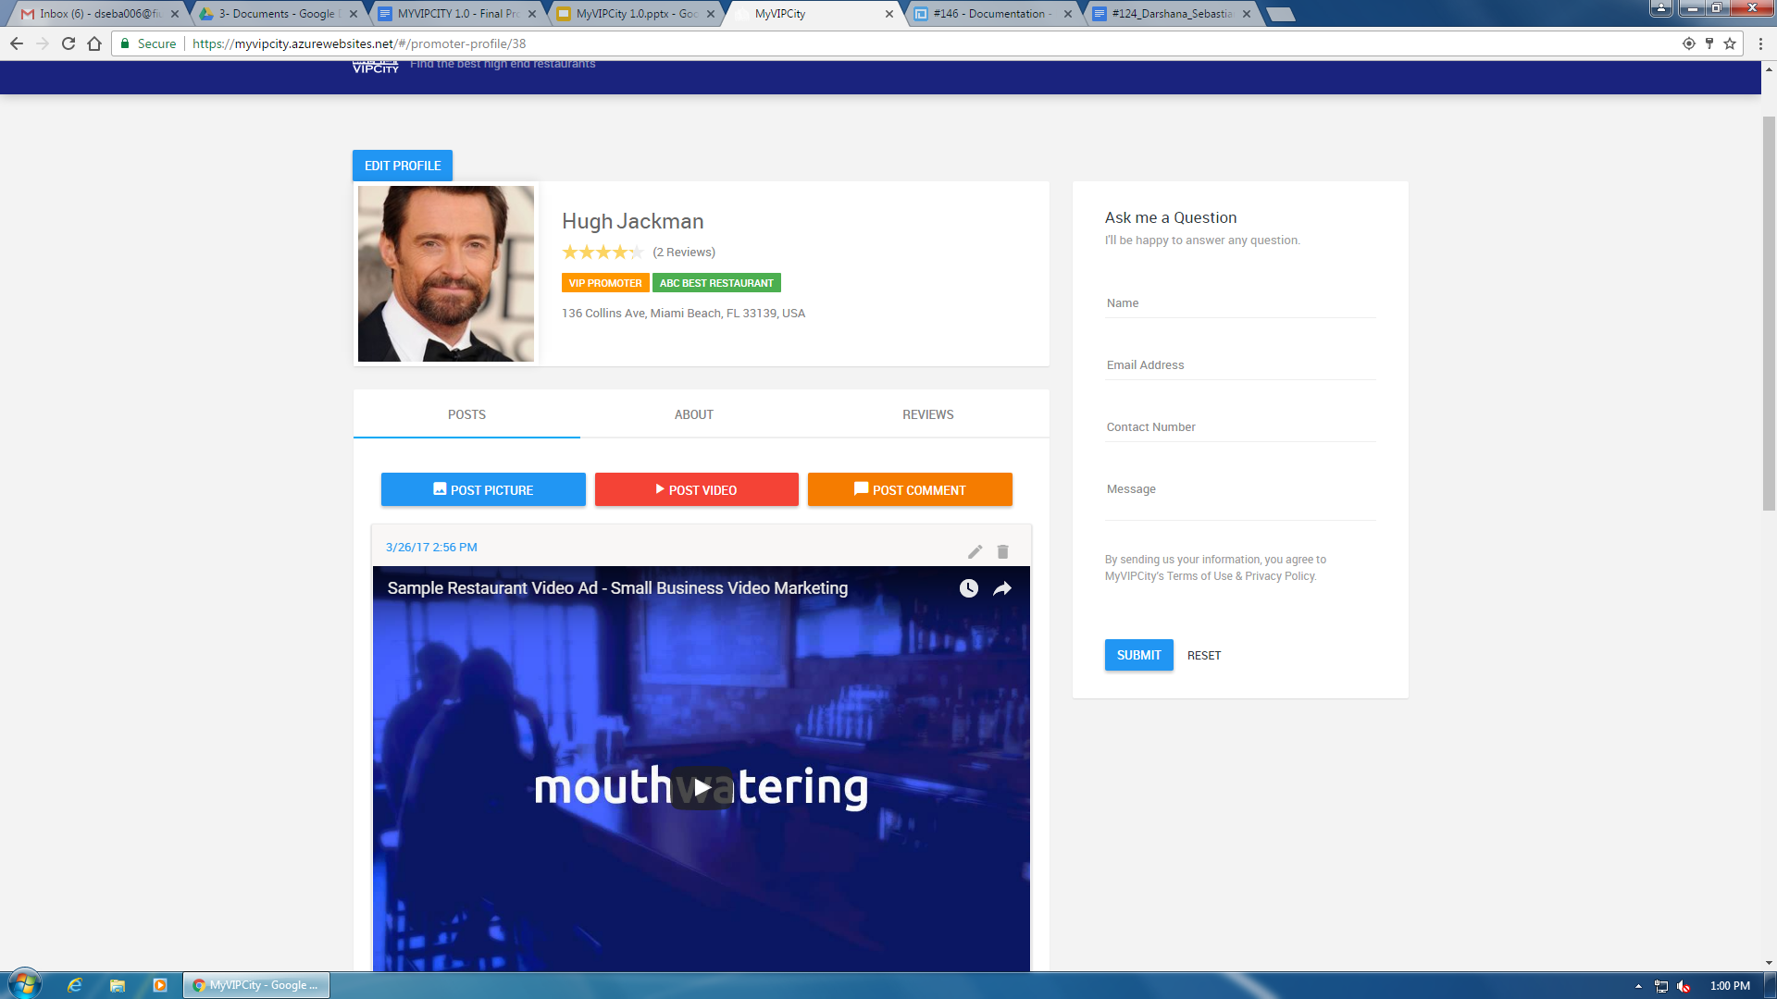

Fig : promoter profile

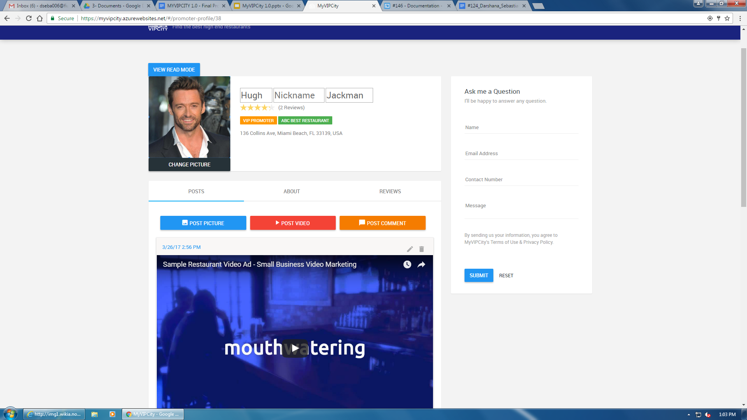

Fig : Editing promoter profile

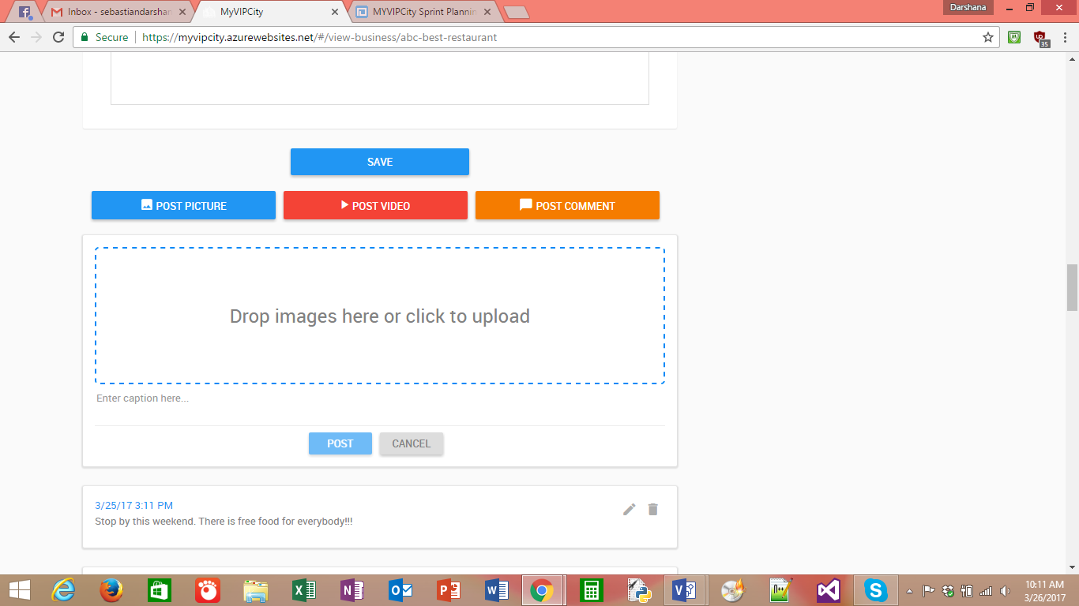

Fig : Admin adding posts to a business

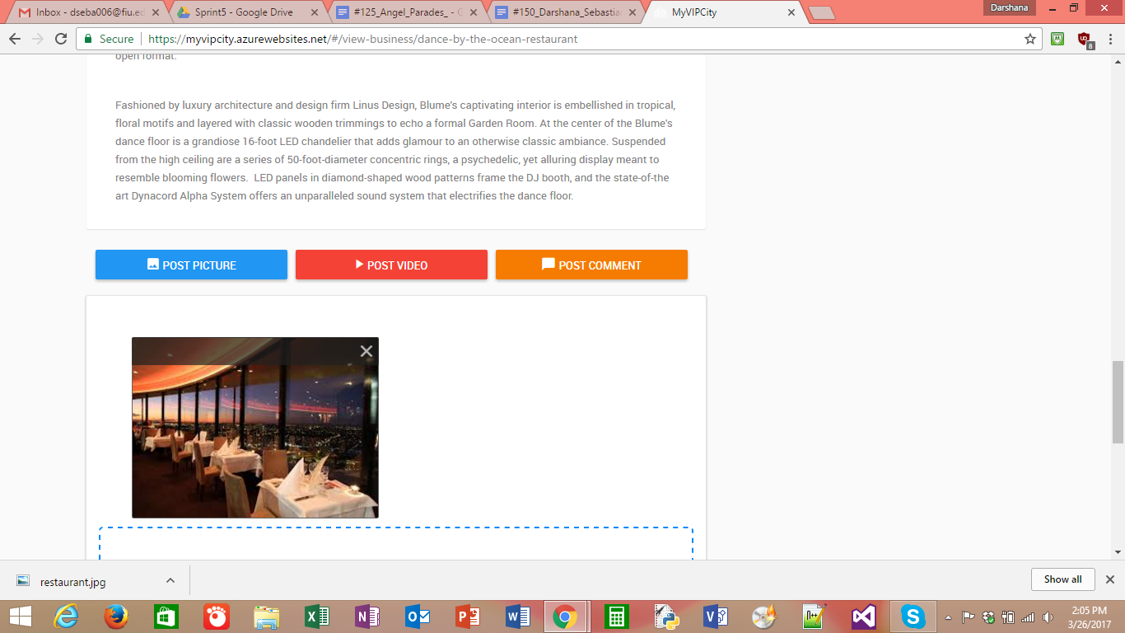

Fig : Admin posted a picture

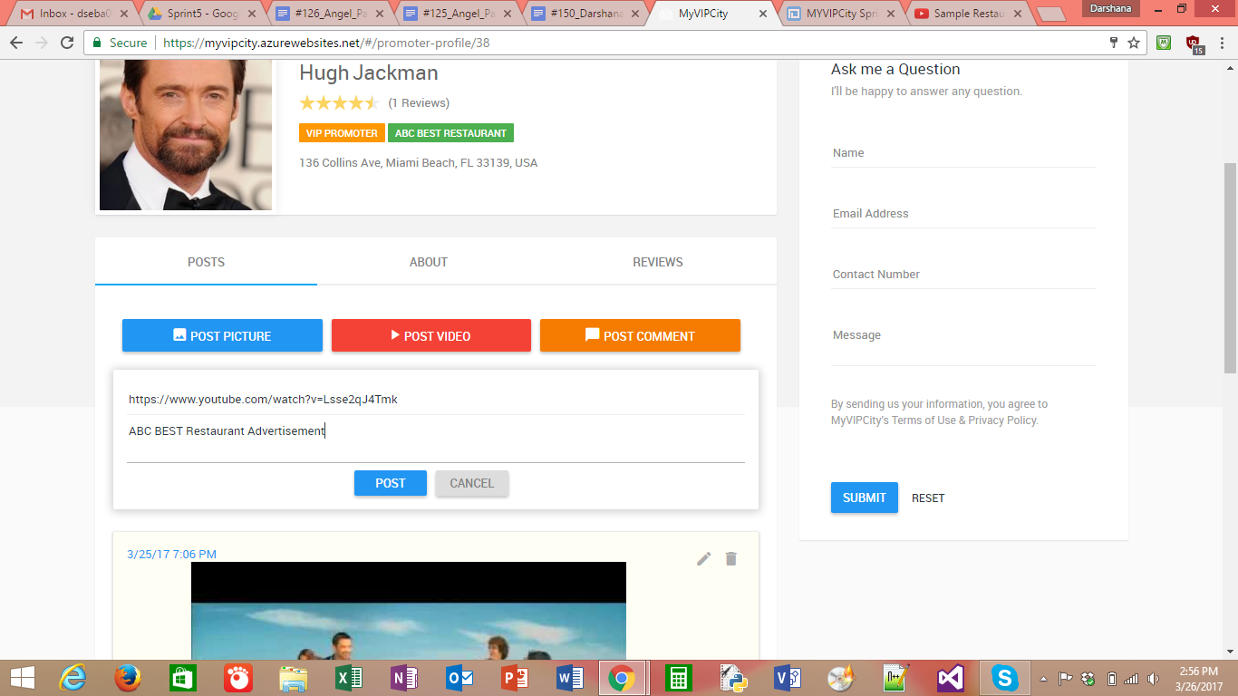

Fig: Promoter profile

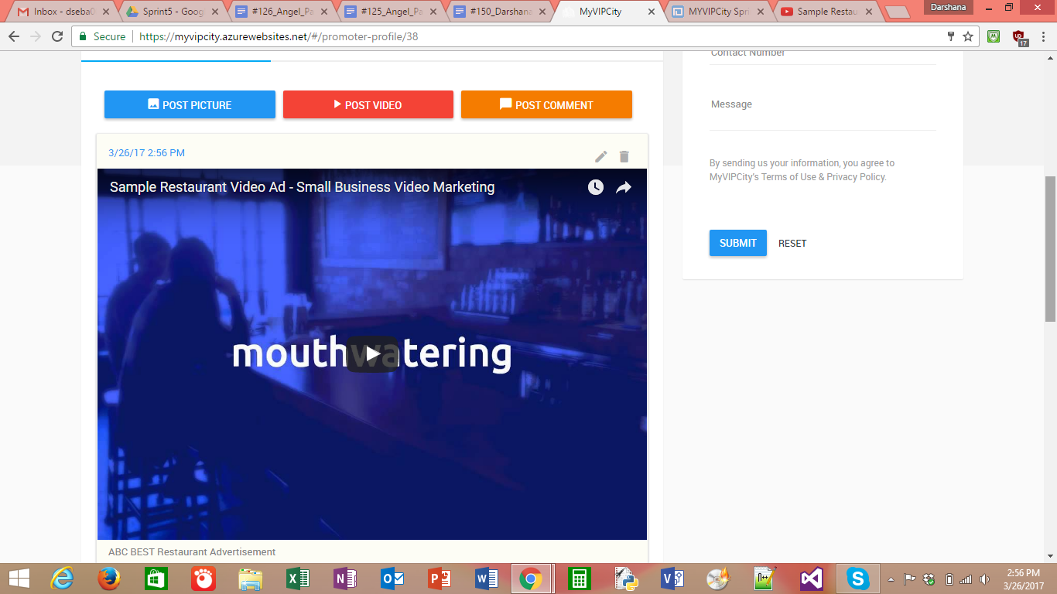

Fig : Promoter posting a video to his profile

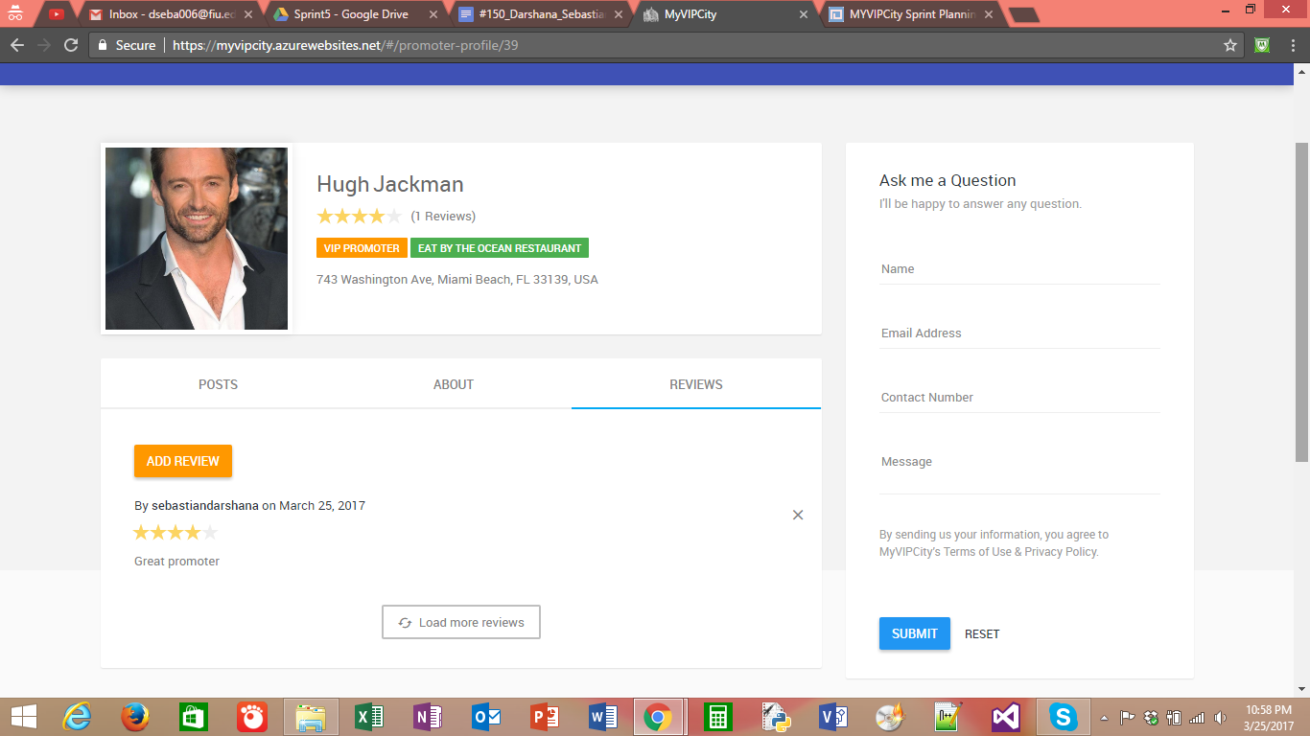

Fig: Promoter review page

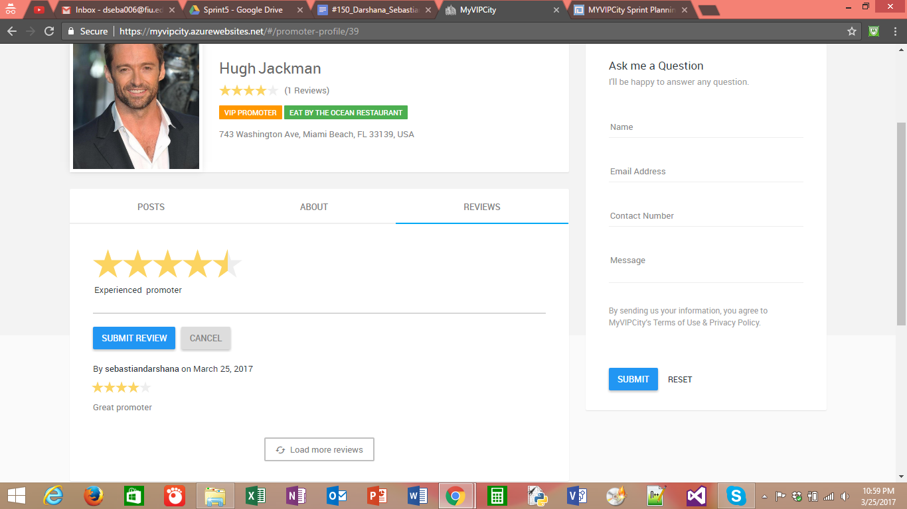

Fig: Adding review

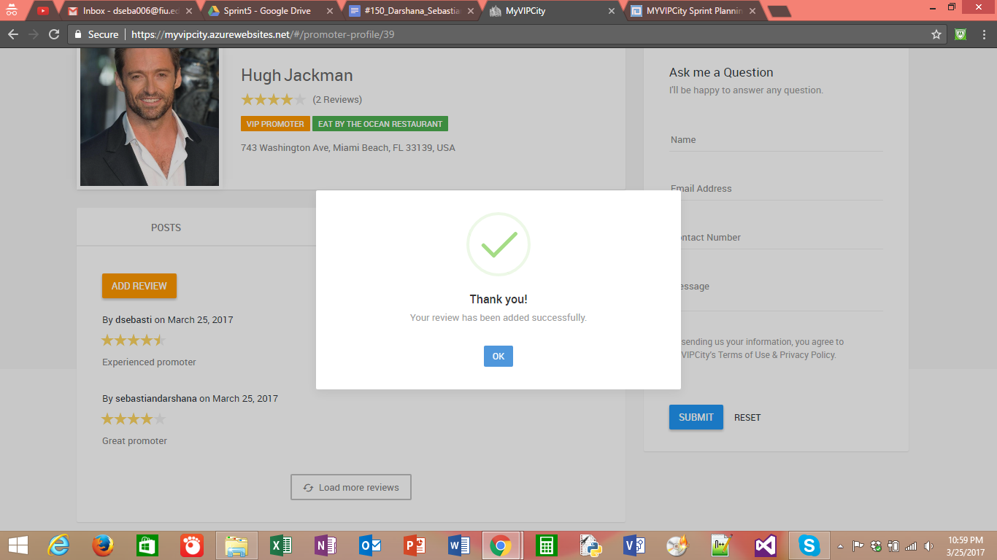

Fig : Message showing the successful posting of a rating

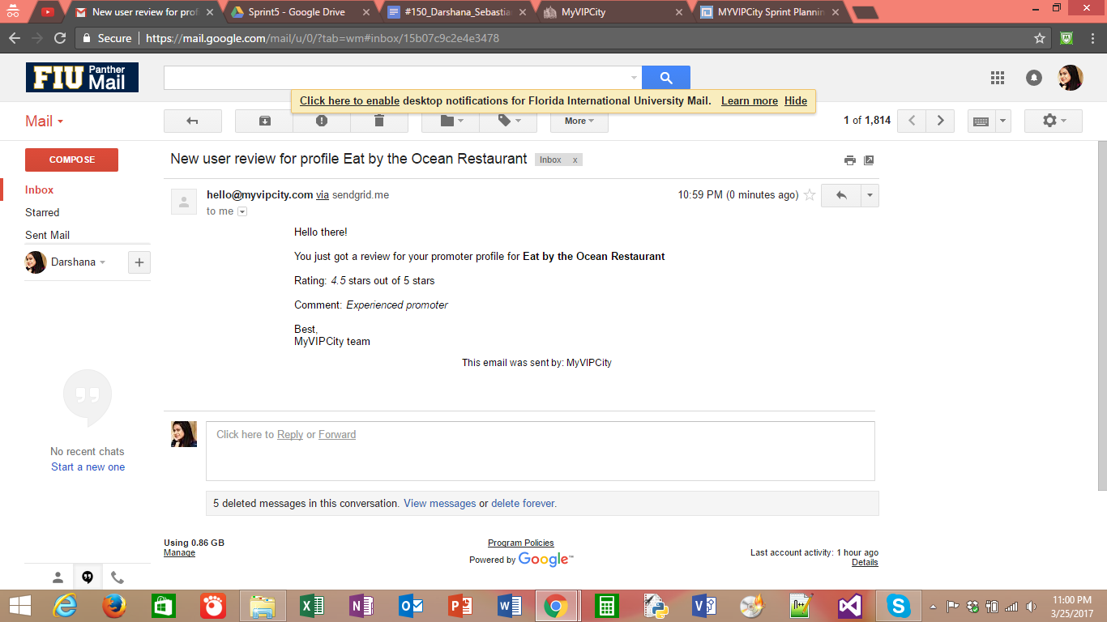

Fig : Email to promoter showing that he received a new review

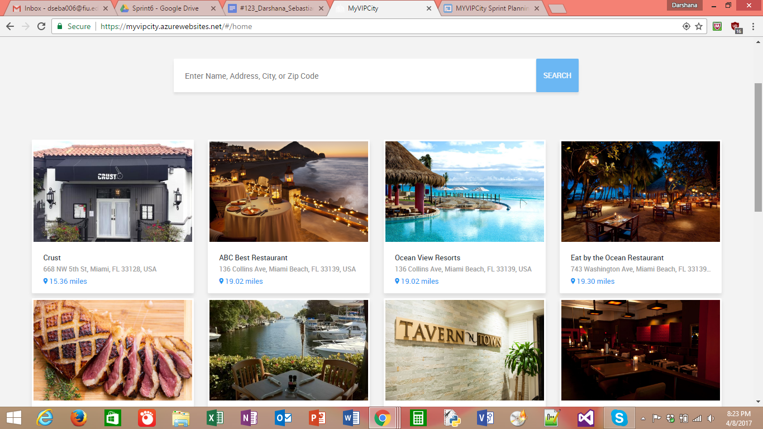

Fig : Home Page

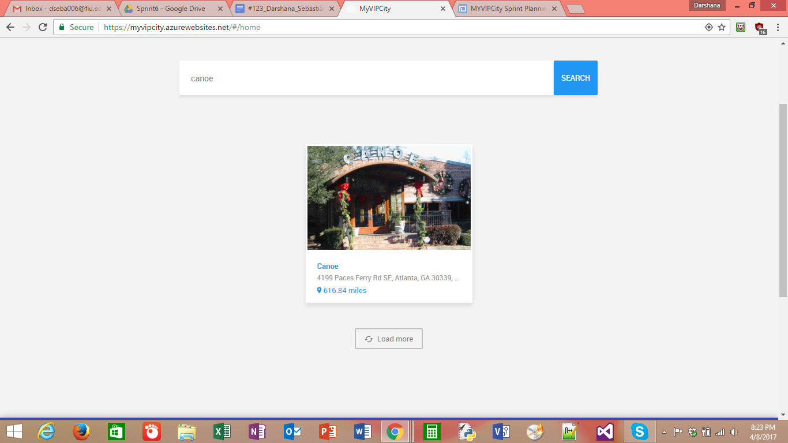

Fig : Searching

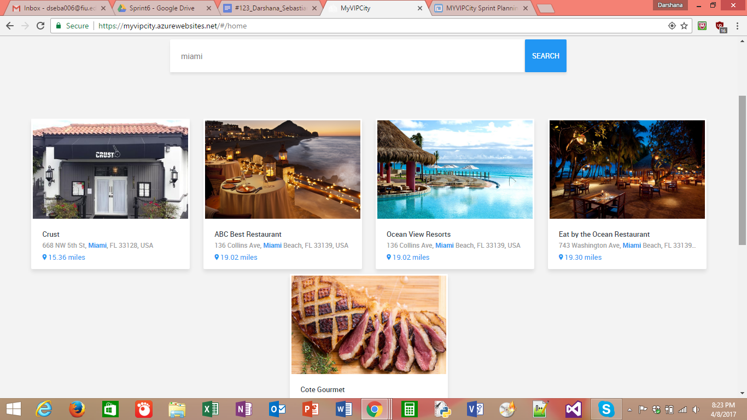

Fig: Search result

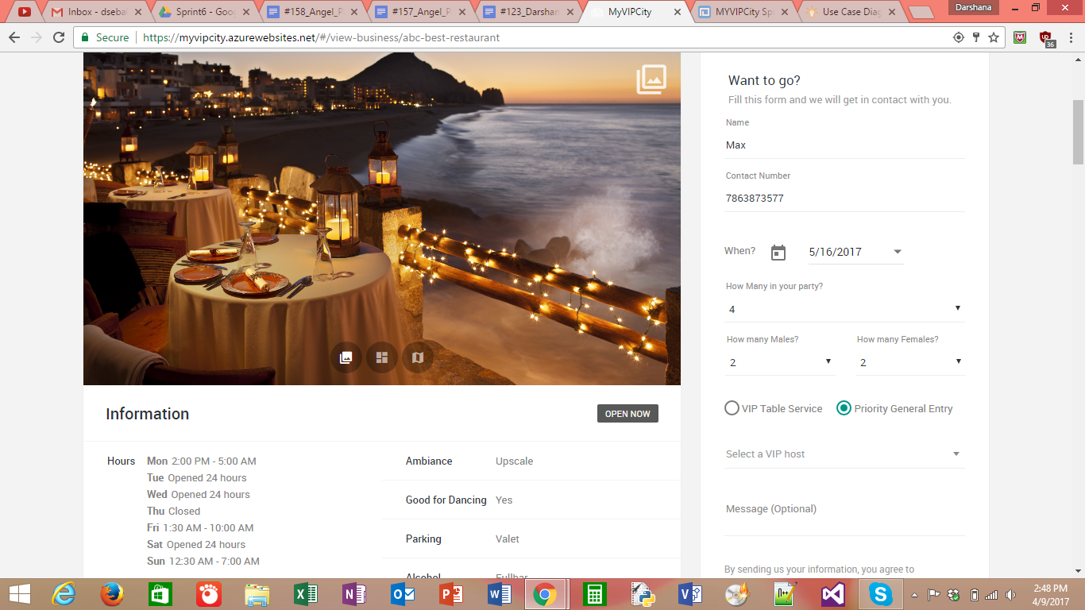

Fig: User giving an attending request to a business

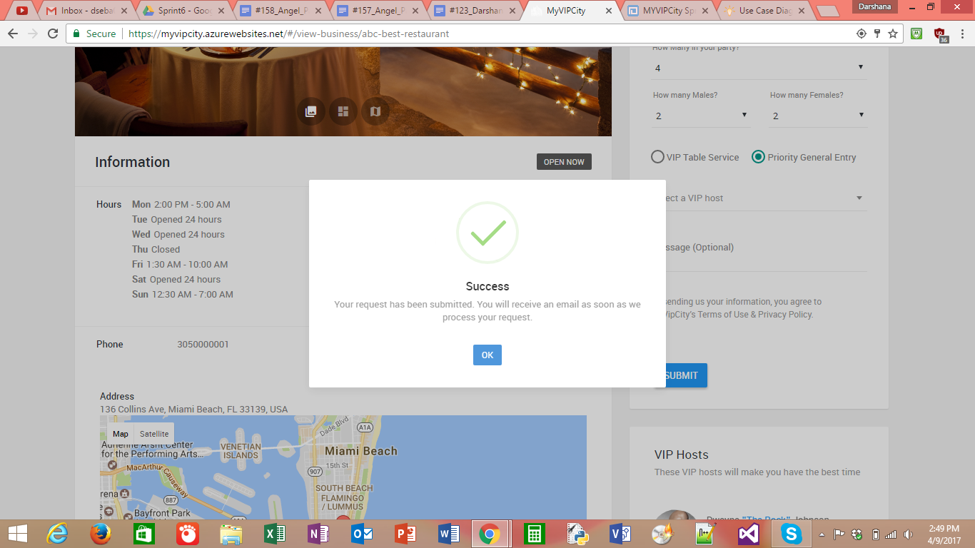

Fig : Confirmation of the request

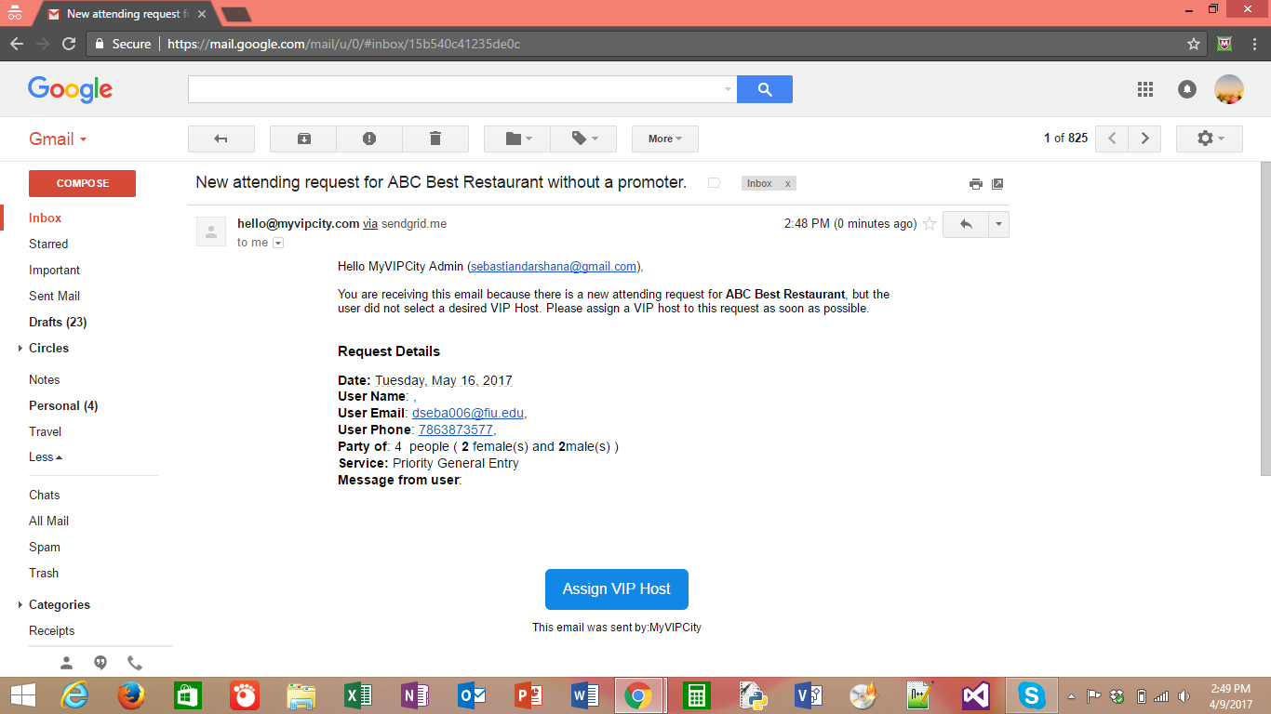

Fig : Email the admin received when a user gave an attending request

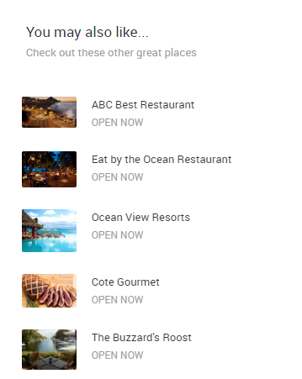

Fig : Places you may like

## Appendix C - Sprint Review Reports

**Sprint 1 & 2**

Attendees: Angel Parades, Darshana Sebastian, Ali Aliabadi,Arash Shivazad,Hamid-reza Nazemi

Start time: 2/10/2017 7:00pm

End time: 2/10/2017 7:20pm

After a show and tell presentation, the implementation of the following user stories were accepted by the product owners: All.

* **# 117 : Create Registration mechanism for regular user/customer**
* **# 118 : Create mechanism to login in the site**

**Sprint 3**

Attendees: Angel Parades, Darshana Sebastian, Ali Aliabadi,Arash Shivazad,Hamid-reza Nazemi

Start time: 2/24/2017 6:00pm

End time: 2/24/2017 6:20pm

After a show and tell presentation, the implementation of the following user stories were accepted by the product owners: All.

* **# 122 : Admin User Can Add a New Business**
* **# 135 : Admin User editing the business(club) details**
* **# 136 : View Business**

**Sprint 4**

Attendees: Angel Parades, Darshana Sebastian, Ali Aliabadi,Arash Shivazad,Hamid-reza Nazemi

Start time: 3/10/2017 5:00pm

End time: 3/10/2017 5:20pm

After a show and tell presentation, the implementation of the following user stories were accepted by the product owners: All.

* **# 120 : Admin User can manage the VIP promoters for the business**
* **# 121 : A promoter can accept the invitation to join a business**
* **# 124 : Edit Promoter Profile**

**Sprint 5**

Attendees: Angel Parades, Darshana Sebastian, Ali Aliabadi,Arash Shivazad,Hamid-reza Nazemi

Start time: 3/24/2017 6:00pm

End time: 3/24/2017 6:20pm

After a show and tell presentation, the implementation of the following user stories were accepted by the product owners: All.

* **# 125 : Admin User Can Add posts for a business and all users can see the posts**
* **# 126 :Promoter User can Add posts for a profile and all users can see the posts**
* **# 150 : Users can add reviews to a promoter profile**

Attendees: Angel Parades, Darshana Sebastian, Ali Aliabadi,Arash Shivazad,Hamid-reza Nazemi

Start time: 4 /7/2017 6:00pm

End time: 4 /7/2017 6:20pm

After a show and tell presentation, the implementation of the following user stories were accepted by the product owners: All.

* **# 123 : Search and Filtering of businesses**
* **# 157 : User can submit an attending request for a restaurant.**
* **# 158 : From the view of a business, suggest other businesses to the user**

## Appendix D - User Manuals, Installation/Maintenance Document, Shortcomings/Wishlist Document and other documents

**Installation**

1. Install Visual Studio (Recommended 2015 or higher)
2. Install Microsoft SQL Server
3. Install IIS
4. Download the project files from the source control repository (<https://github.com/FIU-SCIS-Senior-Projects/MYVIPCity-1.0>)
5. Under the folder Code, open MyVipCity.sln (This is the solution containing all the projects)
6. Make sure the project MyVipCity is set as the default (StartUp) project

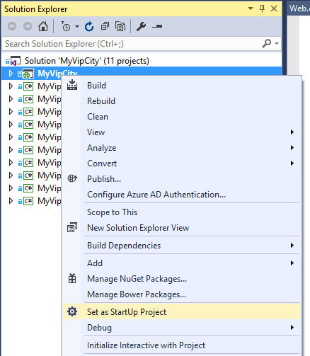

7. Open the file Web.Config under MyVipCity project, and find the connection strings section. Make sure you add a connection string with the proper data source (sql server name/address), initial catalog (database name) username and password.

This is an example of a connection string we use when we deployed the application in Azure

<add name="DefaultConnection" connectionString="Data Source=myvipcity.database.windows.net,1433;Initial Catalog=MyVipCityDev;Persist Security Info=True;User ID=myvipcity;Password=*thisisnottherealpassword*" providerName="System.Data.SqlClient" />

This is an example of a connection string when we deployed the application locally in the IIS installed in the development machine.

<add name="DefaultConnection" connectionString="Data Source=ANGWS;Initial Catalog=MyVipCityDev;Integrated Security=SSPI;" providerName="System.Data.SqlClient" />

8. Now we are ready to create a fresh database. We used Entity Framework Code First, which means we did not have to write any transact-sql code to generate the tables backing up our data. The database and tables are automatically created by Entity Framework using our Domain classes.

9. Open the Package Manager Console (VIEW -> Other Windows -> Package Manager Console)

10. Type **update-database** and hit Enter. Add **-Verbose** if you want to see the SQL code that is automatically generated to build up the database.

11. At this point you can click the run button and the application will open in the selected browser.

12. To deploy the application, you can right click the MyVipCity project and click Publish. Then you can deploy the application to your file system, to an FTP server, or to a Web Server. For MyVipCity 1.0 we used a Web Deploy profile that deployed directly to Azure.

# References

AngularJS <https://angularjs.org/>

SimpleInjector <https://simpleinjector.org>

WebApi2 Tutorial <https://docs.microsoft.com/en-us/aspnet/web-api/overview/getting-started-with-aspnet-web-api/tutorial-your-first-web-api>

Automapper <http://automapper.org/>

Entity Framework Code First <http://www.entityframeworktutorial.net/code-first/entity-framework-code-first.aspx>

SendGrid <https://sendgrid.com/docs/API_Reference/api_v3.html>

For a comprehensive list of third party libraries used on the client side code you can view the file bower.json located in /[Code](https://github.com/FIU-SCIS-Senior-Projects/MYVIPCity-1.0/tree/master/Code)/[MyVipCity](https://github.com/FIU-SCIS-Senior-Projects/MYVIPCity-1.0/tree/master/Code/MyVipCity)/[Scripts](https://github.com/FIU-SCIS-Senior-Projects/MYVIPCity-1.0/tree/master/Code/MyVipCity/Scripts)/[vendors](https://github.com/FIU-SCIS-Senior-Projects/MYVIPCity-1.0/tree/master/Code/MyVipCity/Scripts/vendors)/bower.json in the source control repository.

For a comprehensive list of third party libraries used on the server side code, you can right click the opened solution in Visual Studio, and click **Manage NuGet Packages for Solution**. Once NuGet is opened, click the tab **Installed** and you will see the full list.